Annex A
Development Department
Council Offices, Church Walk, Clitheroe, Lanes,. BB7 2RA
Tel: (01200) 425111 Fax:(01200)414487 DX: Clitheroe 15157

Location Plan
MapRef: SD7737NE Scale: 1:1250
RIBBLE VALLEY BOROUGH COUNCIL

This map is reproduced from Ordnance Survey material with the permission of Ordnance Survey on behalf of the Controller of Her Majesty's Stationery Office © Crown copyright. Unauthorised reproduction infringes Crown copyright and may lead to prosecution or civil proceedings.
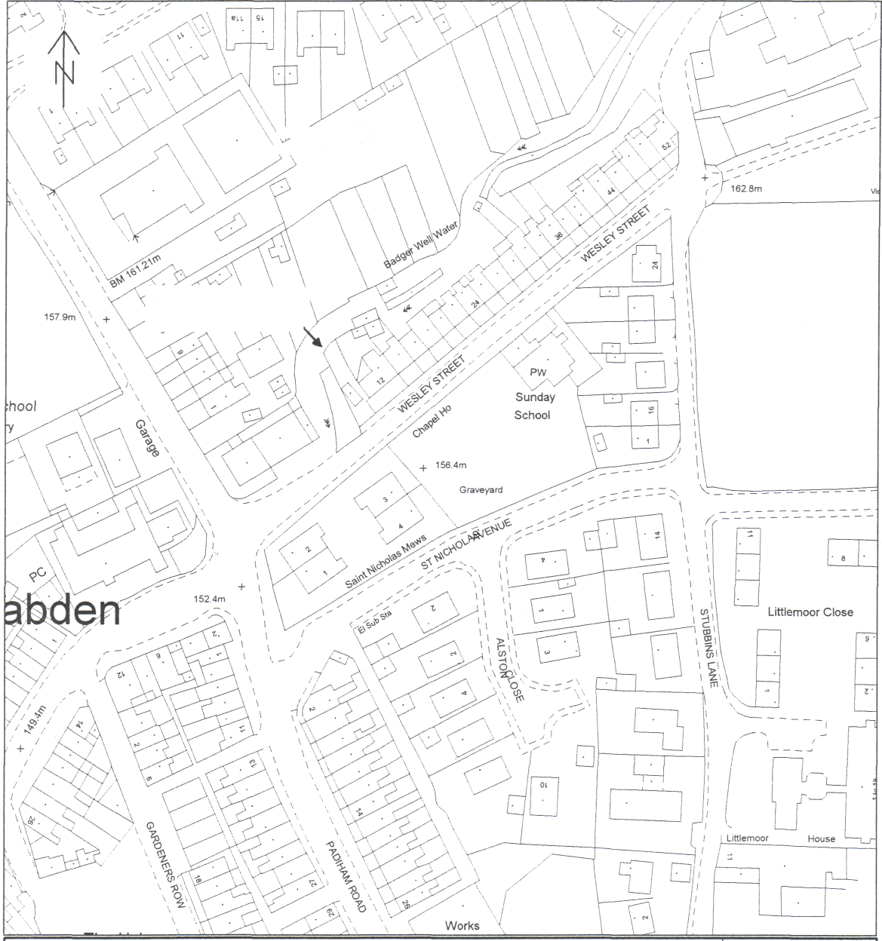
xi/ Baptist Ch \\and Nursery Sch
Culvert Collapse
\f S\ \ V ^
This copy has been produced specifically for map return scheme purposes only. No further copies may be made. Ribble Valley Borough Council. Licence No. LA 100018641 11 July 2007
RECEIPT NO.
SOLD BY

