
Employee Satisfaction Survey
March 2007
Full Report

Executive Summary 3
Methodology 3
Response Rates 3
Profile of respondents 3
The Council as an Employer 3
Work – Life Balance 3
Human Resource Issues 3
Communications 4
Customer Focus 4
Change 4
Management Style 4
Structures and services 4
Training and Development 4
Conclusions 5
Background and Methodology 6
Background 6
Aims and Objectives of Research 6
Context to the research 7
Methodology 7
Response Rates 7
Figure 1.1: Response Rates to East Lancashire Authorities’ Employee Surveys 7
Source: Employee Surveys 2004 and 2006 7
Figure 1.2: Response Rates to Employee Survey 8
Service Areas 8
Figure 1.3: Respondents by service area 8
Figure 1.4: Respondents by council building 9
Grade 9
Figure 1.5 Grade of respondents 9
Retention within the Council 9
Figure 1.6: Respondents employment with Council (% of Respondents) 10
Figure 1.7 Retention by grade 10
Figure 1.8 Grade by retention 10
The Council as an Employer 11
Opportunities for progression 11
Figure 2.1: Opportunities exist for my career to progress at Ribble Valley Borough Council 11
Pay and Conditions 12
Figure 2.2: Pay and conditions 12
Organisational Pride 13
Figure 2.3: Organisational pride amongst Employees 2006 13
Figure 2.4: Organisational pride amongst Employees 2004 14
Workloads and Work–Life Balance 15
Work and Stress 15
Figure 3.1 Workplace Stress 15
Work – life Balance 15
Figure 3.2: Work – Life Balance Issues 16
HUMAN RESOURCES Issues 17
Employee Support 17
Figure 4.1: Employee Support Infrastructure 17
Figure 4.2: Employee Support Infrastructure 18
Pay / Pay Slips 18
Figure 4.3: Pay and Pay Slips 18
FLOW OF INFORMATION 19
Information Channels 19
Figure 5.1: Information and Communication 19
Figure 5.2: Information Channels and ‘rumours’ 20
Figure 5.3: Improvement in communications over past three years 21
Staff Newsletter - Backchat 21
Figure 5.4: Readership of the Staff Newsletter 21
Verbatim Responses 21
Customer Focus 23
Customer Focus 23
Figure 6.1: Customer Focus 23
Customer Feedback 23
Figure 6.2 Customer Feedback 24
Change 25
Organisational Change 25
Figure 7.1 Organisational Change 25
Job Related Change 26
Figure 7.2: Change related to job 26
Management Style 27
Relationship with Line Manager 27
Figure 8.1: Employee Relationship with their Line Manager 27
General Management Issues 28
Figure 8.2: General Management Issues 28
Figure 8.3: Management issues 29
Verbatim Comments 29
Structures and Services 30
Service Areas 30
Figure 9.1: Organisational issues – Service Areas 30
Organisational Structure 31
Figure 9.2: Organisational structure 31
Figure 9.3: Perception of organisational structures 31
Training and development 32
Figure 10.1: Training and Development 32
VERBATIM COMMENTS 34
Communications 34
Service Improvements and Prioritisation 34
Working Conditions 34
Team Building 35
Working Environment 35
Other 35
Recommendations and issues arising from the research 36

Executive Summary
Methodology
Either an email or paper based survey was sent to all staff. The questionnaire was based on questions designed by a group of Personnel Managers across the County and it is hoped that Ribble Valley will be able to benchmark its results with other local councils. The finalised questionnaire was sent out with employees given four weeks to complete the survey.
Response Rates
In total 51.66% of the staff responded. Overall this is a good response rate, but replies were disappointing from some service areas such as Street Scene (18.9%), IT (33.3%), Revenues and Benefits (35.4%) and Legal Services (36.4%).
The response rates to previous surveys are - in 2001 around 50%, in 2004 53%.
Profile of respondents
The majority of respondents (51.9%) are scale 1-6 (see figure 2.1) with only 9% of those who responded being a Senior Officer (SO) (22.5% were Senior Officer, Principal Officer or above) this is indicative of a low number of responses from more senior officers. In comparison to the 2004 survey fewer manual workers have responded this time and more people have not given a response.
Staff tend to stay at Ribble Valley for some time, 32.1% have worked for the council for over 10 years, 44.3% over 6 years and nearly 70% have been with the Council for over 3 years indicating that there is a very stable workforce.
The Council as an Employer
Career opportunities, particularly for Senior and Principal Officers and above, are perceived as being limited. However, the Council is felt to offer employees a safe and healthy work environment. Whilst ‘pay’ is thought by some respondents as not being comparable to other Councils, the holiday entitlements are good.
Only 6.4% of respondents did not think that Ribble Valley Borough Council is a good organisation to work for and only just over 10% (12.2%) of respondents were not satisfied with their job.
The perception of external forces impacting on the Council is high, with only a minority of respondents (31.4%) feeling that the future of Ribble Valley Borough Council is promising.
Work – Life Balance
There is evidence that a significant proportion of respondents (24.3%) find the working environment stressful which is an increase on the 2004 results. 28.2% of respondents feel stressed as a result of work. To balance this, the flexible working policy is highly regarded by employees and nearly 45% of respondents feel that it contributes to the work–life balance.
Human Resource Issues
On the whole staff are very positive about the HR services provided by Ribble Valley Borough Council and the Employee Handbook is felt to be useful. Payroll services are perceived as providing a reliable and accurate service.
Communications
Communications are felt to have improved over the past three years. Most employees feel well informed about the Council’s Ambitions and performance of the council. The Staff Newsletter – Backchat - is also well received by staff.
However, formal communications and in particular senior managers listening to employees and communications between service areas, is still felt by a significant proportion of respondents to be in need of improvement.
Customer Focus
The customer focus and quality of services provided by Ribble Valley Borough Council is perceived as being good. A significant proportion of employees (72.7%) feel that we show a good attitude to customers. More than half of all employees feel that opening hours of the council meet the needs of some customers. Many employees feel that they do not receive sufficient customer feedback. Only 40% of employees receive limited amounts of customer feedback, with a further quarter of employees saying they do not receive customer satisfaction data. Nearly all employees feel that their customers are satisfied with service they provide at least sometimes.
Change
Whilst the majority of staff (62.8%) feel that the Council needs to change in order to improve, a considerable number of staff (24.4%) feel that there have been too many changes. Some staff (46.8%), particularly Manual Grade employees also feel that have not been sufficiently involved in changes which impact on their job.
Management Style
Managers on the whole are well regarded by their teams; support and praise are felt to be given to employees by their managers. Less positive is employees’ perceptions of Senior Managers with Manual grade employees in particular feeling remote from them. The majority of respondents feel that through performance appraisals they know what their key accountabilities are and their annual objectives.
Structures and services
Whilst most employees understand what their particular Service Area does, over a quarter of respondents do not feel that they are sufficiently well informed about the work of other service areas.
Only a minority of respondents felt that the council operates as one big team with nearly 45% actively stating that this was not the case. Only just over a quarter of respondents feel that Councillors value the work of their service area.
Training and Development
Most staff are happy about the training which is provided by the Council but there are some exceptions – mostly being Manual workers who perceive training as the preserve of the few.
Only 80% of all respondents agree that they have had a performance appraisal in the last 12 months. This is a massive improvement from 2004.
Conclusions
The Council is clearly getting a lot of things right, welfare facilities and the work-life balance schemes are regarded positively by employees. Line managers are also felt by most staff to provide a supporting working environment.
This does not mean though that all issues are resolved. Clearly some service issues have been raised by this research which warrant consideration and action. These include:
- Workplace stress needs to be examined and actions developed to ameliorate the problem.
- More cross-working between service areas needs to be encouraged to break down the barriers which exist between them and to maximise the synergies which can be gained from adopting a more holistic and project based approach to working.
Generally the same issues are coming up as were raised in the 2004 survey, although there have been a few very noticeable improvements such as the increase in the percentage of staff receiving performance appraisals in the last 12 months.
Where there have been noticeable differences in the results, reference has been made to the results of the 2004 survey for comparison.
Background and Methodology
Background
In line with the national best practice for Human Resource Management within local government an Employee Satisfaction Survey was conducted amongst the employees of Ribble Valley Borough Council during October and November 2006. The survey was built upon the previous survey conducted in June/July 2004 and was developed in the following ways:
- The questionnaire was designed using the new SNAP software procured as part of the East Lancashire e-Partnership. This made analysis of the results faster and also offered employees the opportunity to complete the questionnaire "on line" via email. The software has protocols set up within it to allow respondents to reply in complete anonymity.
- The survey was developed utilising a cross-organisational collaborative approach. All partners in the East Lancashire e-Partnership will use the core questionnaire. The majority of the questions in the questionnaire were designed by a working group of Personnel Managers across Lancashire; this means that at a later date following surveys across the county, we will be able to "benchmark" ourselves against other Lancashire authorities. A core of questions from our previous employee surveys was also retained, where issues were not covered by the joint questions.

The key issues explored in
the research were:
- The Council as an employer examining issues such as pay, organisational pride and job satisfaction;
- Workloads and work life balance;
- Satisfaction with the Council’s Personnel Services;
- Communication issues such as formal communications and Staff Newsletters;
- Customer focus and customer satisfaction;
- Change and employees involvement in change;
- Management issues, both line management and the relationship of employees with senior managers;
- Structure and the role of service areas;
- and finally opportunities for employees to access training and development.
Aims and Objectives of Research
The research has several important strategic applications within our organisation and will provide:
- Contextual information to be used in the continual development of managers;

- Intelligence on the culture of our organisation that can be measured against previous surveys to show change over time;

- Provide information on the effectiveness of particular schemes such as flexible working hours and our official communication methods;

- Give employees an opportunity to provide Corporate Management Team (CMT) and service manager’s feedback on key organisational issues that impact on their working environment;

- Evidence for potential IIP accreditation;
- Contextual information to feed
- into future reviews and CPA.
Context to the research
It should be noted that this research is set within an organisational context of change and uncertainty with, for example, issues such as the potential local government re-organisation and job evaluation, being almost certain to have shaped the responses to this survey.
Methodology
As previously mentioned a self-completion questionnaire methodology was employed in this research with the SNAP survey software being used to email the survey. Employees who did not have access to a PC were sent the questionnaire by post.
The process proved to be highly efficient with the level of data entry being considerably reduced. Responses were swift with around 50% of surveys returned within the first two weeks.
There has been widespread support for the email methodology in that it was “easy to complete”, “clear” and “well laid out”. Initially three weeks were allowed for completion of the survey with one reminder being sent out to increase the response rate.

Response Rates
The overall response rate is 51.66%. When broken down this showed that 46.79% responded by paper and 53.2% responded by e-mail.
Comparisons with other East Lancashire authorities’ most recent surveys shows that the average response rate of other authorities is 43.5%.
Figure 1.1: Response Rates to East Lancashire Authorities’ Employee Surveys
Authority | Response rate
Burnley (2006) | 54%
Hyndburn (2004) | 49%
Pendle (2004) | 38%
Rossendale (2006) | 33%
Source: Employee Surveys 2004 and 2006
Whilst the overall response rate of around 52% is good for this type of methodology, figure 1.2 shows that the response rates were uneven across the different service areas, ranging from 18.9% to 89.5%. Service areas that have a high level of manual workers/ low levels of PC usage were the least likely to respond and actual response rates show this. These response rates ranged from 18.9% to 65.5%.
Figure 1.2: Response Rates to Employee Survey
 | Total Employees in service area | Response (number) from service area (email) | Response (number) from service area (paper) | Response Rate (%)
Revenues and Benefits | 29 | 4 | 6 | 34.5
Financial Services | 19 | 10 | 7 | 89.5
Corporate Services (inc. CEX and HR) | 30 | 13 | 4 | 56.7
Legal Services | 11 | 3 | 1 | 36.4
Environmental Health | 12 | 3 | 2 | 41.7
Housing | 39 | 10 | 6 | 41.0
IT | 6 | 2 | 0 | 33.3
Street Scene (Engineering, Parks and Open Spaces, Waste Management) | 74 | 3 | 11 | 18.9
Community Development (C&D, Sports, Culture and Recreation) | 55 | 13 | 23 | 65.5
Forward Planning and Regeneration | 8 | 4 | 0 | 50.0
Development and Building Control | 20 | 11 | 1 | 60.0
No reply |  | 7 | 12
Total | 302 | 83 | 73 | 51.66
Source: Employee Survey 2006

Service Areas
The service area which makes up the largest proportion of respondents to the Employee Survey is Community Development. IT, Legal Services and Forward Planning make up the smallest proportion of respondents (see figure 2.1).
Figure 1.3: Respondents by service area
 | % of all respondents (156) | Respondents as % of authority’s employees (302) | % of all staff employed in each service area (302)
Revenues and Benefits | 6.4 | 3.3 | 9.6
Financial Services | 10.9 | 5.6 | 6.3
Corporate Services (inc. CEX and HR) | 10.9 | 5.6 | 9.8
Legal Services | 2.6 | 1.3 | 3.6
Environmental Health | 3.2 | 1.7 | 4.0
Housing | 10.3 | 5.3 | 12.8
IT | 1.3 | 0.7 | 2.0
Street Scene (Engineering, Parks and Open Spaces, Waste Management) | 8.9 | 4.6 | 24.5
Community Development (C&D, Sports, Culture and Recreation) | 23.1 | 11.9 | 18.2
Forward Planning and Regeneration | 2.6 | 1.3 | 2.6
Development and Building Control | 8.9 | 4.0 | 6.6
No reply | 12.2 | 6.3
Source: Employee Survey 2006
Figure 1.4: Respondents by council building

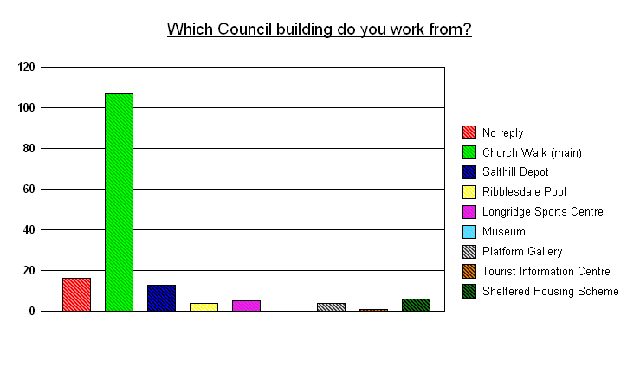
Source: Employee Survey 2006
Grade
The majority of respondents (51.9%) are scale 1-6 (see figure 2.1) with only 9% of those who responded being a Senior Officer (SO). In comparison to the 2004 survey fewer manual workers have responded this time and more people have not given a response.
Figure 1.5 Grade of respondents

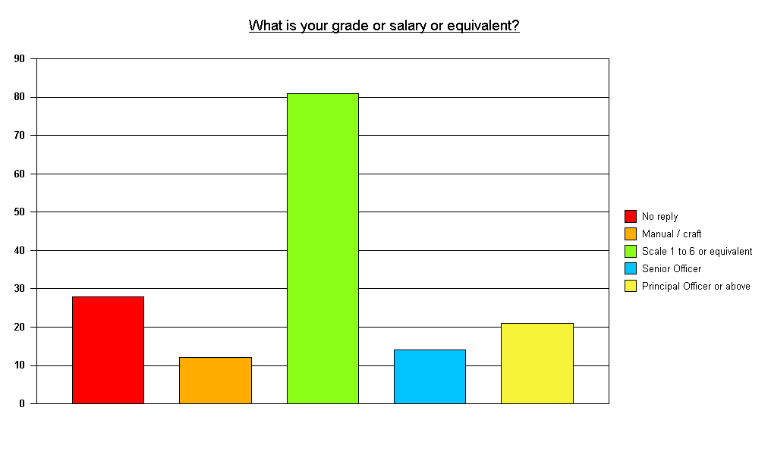
Source: Employee Survey 2006
Retention within the Council
Nearly one third of the respondents, (32.1%), have been employed by Ribble Valley Borough Council for over 10 years with nearly 70% having been with the Council for over 3 years indicating that there is a very stable workforce.
Figure 1.6: Respondents employment with Council (% of Respondents)
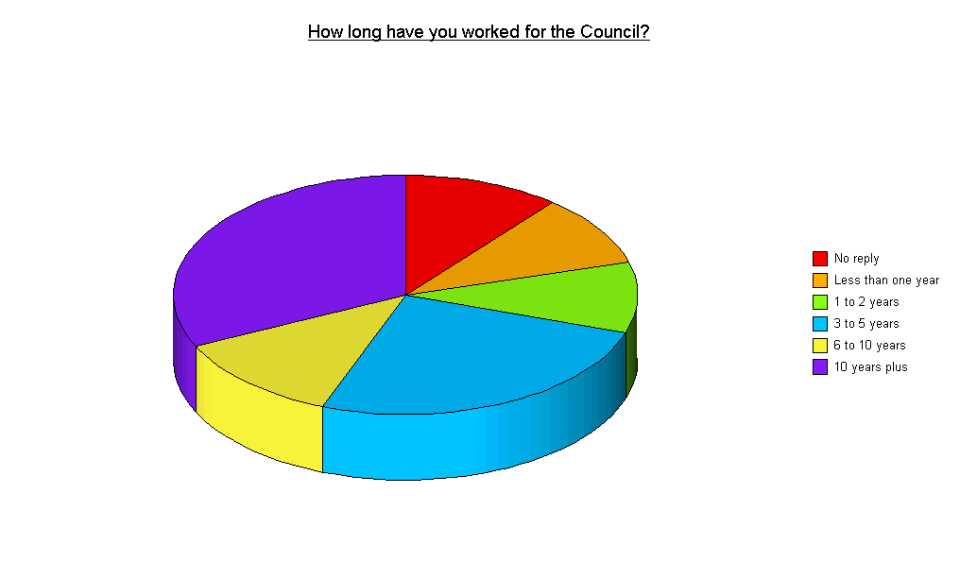
Source: Employee Survey 2006
Figure 1.7 Retention by grade
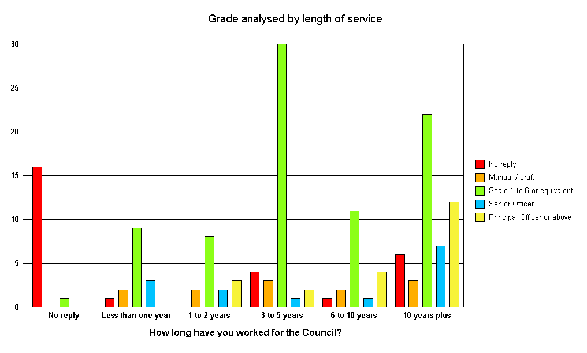
Source: Employee Survey 2006
Figure 1.8 Grade by retention
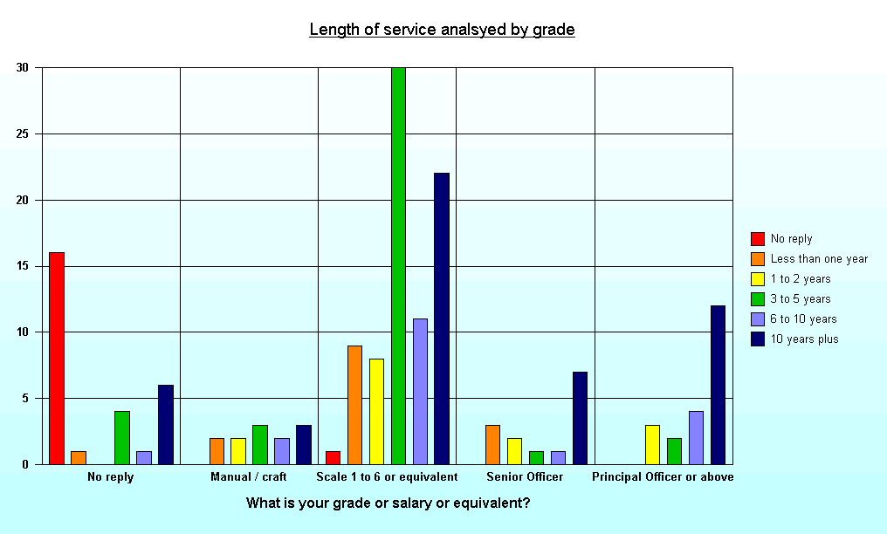
Source: Employee Survey 2006
The Council as an Employer

The first part of the survey asked how respondents felt about the Council as an employer.
KEY ISSUES
- Less than a quarter of employees feel that the Council offers good opportunities for progression.
- Only 14.8% of employees feel that pay levels are comparable to other local Authorities.
- Less than 10% of employees feel that the Council doesn’t provide a safe and healthy work environment.
- Nearly 60% of employees are happy with their holiday entitlements.
- Very few of the employees (6.4%) who responded to the survey felt that the Council was not a good place to work for.
- Employees are divided in their perception of how secure their employment is. Half of employees (50%) agreed that their job was secure.
- The majority of Employees (60.9%) are satisfied with their job.
- A minority of Employees (11.6%) do not feel proud to work for Ribble Valley Borough Council, but the majority (52%) always feel proud.
- A surprisingly low proportion of Employees (31%) feel that the future for the Council is promising.
Opportunities for progression
A minority of respondents (23.1%) feel that there are good opportunities for career progression within Ribble Valley Borough Council (see figure 5.1 below). There are trends according to the respondent’s career grade in the authority, with 28.6% of officers who are Senior Officer and above and 23.5% of Scale 1-6 respondents perceiving good opportunities for progression compared to 0% of manual/craft grade employees.
Figure 2.1: Opportunities exist for my career to progress at Ribble Valley Borough Council
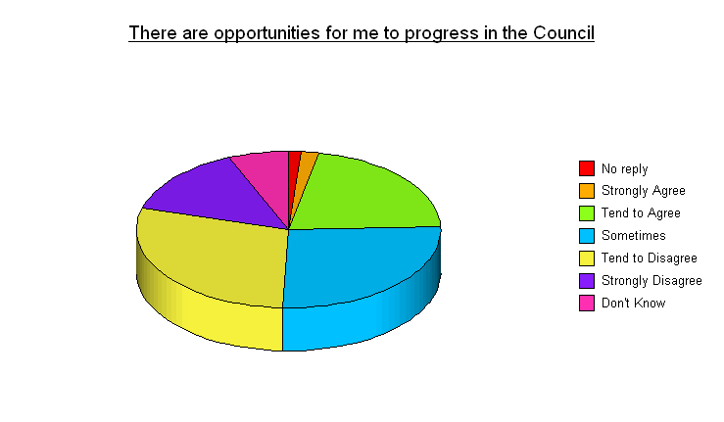

Source: Employee Survey 2006
The career opportunities for service managers within the council appears to be limited and this could have implications for the Council’s potential to retain younger managers or more ambitious employees. However, 38% of Prinicipal Officers feel that there are good opportunities for career progression.
Employees who have been employed by Ribble Valley Borough Council for a significant period of time feel that there are less opportunities for progression with only 13% agreeing that opportunities for personal career progression exist amongst those who have been employed by the Council for over 6 years compared to 43.3% of those who have worked at Ribble Valley for 2 years or less.
Pay and Conditions
There is a significant body of opinion amongst employees that pay levels within Ribble Valley Borough Council are not comparable to other local authorities (see figure 5.2). Only 14.8% of respondents agreed that pay levels are comparable to similar councils, compared to 20.8% in 2004. Grade also strongly influences perception of pay levels, with only 12.3% of scale 1-6, and 14.3% of officers at PO and above feeling that pay levels are comparable compared to 28.6% of SO officers and 25% of Manual Grade employees.
Figure 2.2: Pay and conditions

 | Strongly agree | Tend to agree | Some-times | Tend to disagree | Strongly disagree | Don't know
There are opportunities for me to progress in the Council | 1.9% | 21.2% | 26.3% | 28.8% | 14.1% | 6.4%
Pay levels are comparable with other similar councils | 1.3% | 13.5% | 12.8% | 36.5% | 19.9% | 14.7%
I think my employment is relatively secure | 4.5% | 45.5% | 20.5% | 15.4% | 7.1% | 7.1%
The Council provides a safe and healthy work environment | 10.3% | 55.1% | 22.4% | 5.8% | 3.8% | 0.6%
The Council provides good physical working conditions | 8.3% | 46.8% | 25.6% | 11.5% | 5.1% | 2.6%
My working environment is comfortable | 6.4% | 46.2% | 26.9% | 14.1% | 6.4% | 0.0%
The Council provides good welfare facilities | 5.8% | 42.3% | 16.7% | 9.6% | 2.6% | 20.5%
Holiday entitlements compare favourably with other places | 7.1% | 52.6% | 12.2% | 14.7% | 5.1% | 8.3%
The Council is a good organisation to work for | 9.6% | 47.4% | 34.0% | 5.1% | 1.3% | 1.9%
Overall I am satisfied with my job | 10.9% | 50.0% | 26.3% | 9.6% | 2.6% | 0.0%
I feel proud to work for the Council | 14.1% | 37.8% | 36.5% | 7.1% | 2.6% | 1.9%
The future for the Council is promising | 3.2% | 28.2% | 11.5% | 27.6% | 9.0% | 20.5%
I find it difficult to handle my workload | 5.1% | 5.8% | 32.7% | 44.2% | 10.9% | 0.0%
Source: Employee Survey 2006
Employees are also divided in their perception of how secure their employment is. Half of respondents (50%) agreed that their job was secure – this ranges from 68.7% of respondents in Housing who feel their job is secure to 44.4% of those employed in Community Development and 42.6% in Street Scene. These results may have been influenced by the potential closure of the TIC and discussions regarding Longridge Sports Centre. Manual workers on the whole though feel relatively insecure (only 16.7% agreeing) compared to other grades, for example 55.6% of those at Scale 1-6 and 61.9% of PO officers feel secure.
The Council is felt, on the whole, to provide a safe and healthy work environment (less than 10% of respondents disagreed with this). 50% of Forward Planning staff and 30% of Revenues and Benefits staff disagree that the working environment is good.
Over 55% of respondents agree that the Council provides good physical working conditions although 50% of the respondents who work at the Pool and 60% who work at the Sports Centre disagree.
Over 50% of respondents agree that their working environment is comfortable. 21.5% of respondents from the Church Walk offices disagree as do 40% of the Sports Centre respondents.
Over 48% of all respondents also perceive that Ribble Valley Borough Council provides good welfare facilities, which is an improvement on the 2004 figure of 40%.
Nearly 60% of respondents agreed with the statement that holiday entitlements are good and compare favourably to similar organisations in comparison to two thirds of respondents in 2004. Whilst pay is not felt to be a strength of the council, softer employment issues such as welfare and holidays are highly regarded by a significant majority of respondents.

Organisational Pride
Overall 60.9% of respondents are satisfied with their jobs.
52% of respondents feel proud to work for the Council and this rises to 88.4% when including at least ‘sometimes’.
Only 31% of respondents think the future of the Council is promising, 37% disagreed, and a large minority (20.5%) state they do not know. This perception may have been shaped by worries over unitary status.
Very few of the employees (6.4%) who responded to the survey felt that the Council was not a good place to work for (see figure 5.3). The two charts below show that there has been very little change in responses between the last two surveys.
Figure 2.3: Organisational pride amongst Employees 2006
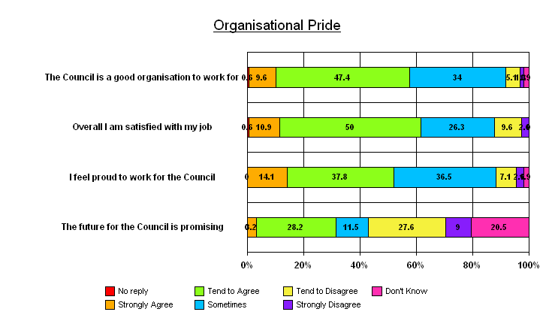
Source: Employee Survey 2006
Figure 2.4: Organisational pride amongst Employees 2004
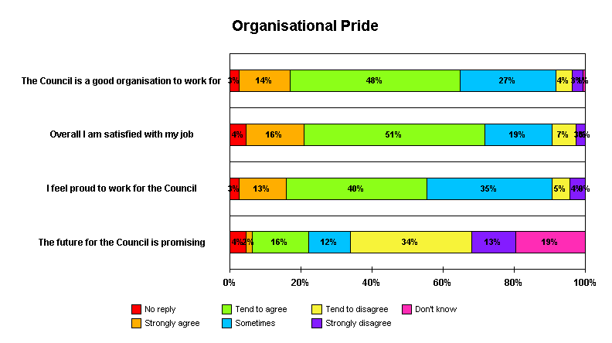

Source: Employee Survey 2004
Workloads and Work–Life Balance
KEY ISSUES
- Work related stress would appear to be an issue for around 30% of Employees on a regular basis, with a further 35% feeling stress sometimes.
- Over a third of employees do not feel valued by the authority.
- The Council is seen to offer its employees a good work / life balance with respondents being positive about the flexible working scheme.
- 44.3% of employees agree that Ribble Valley is a family friendly employer.

Work and Stress
24.3% of respondents feel that the working environment is stressful and a further 44.2% saying it is sometimes stressful. A large minority of respondents, 30.8%, do not find the environment stressful (see figure 3.1)
Figure 3.1 Workplace Stress

 | Strongly agree | Tend to agree | Some-times | Tend to disagree | Strongly disagree | Don't know
My working environment is stressful | 9.6% | 14.7% | 44.2% | 23.7% | 7.1% | 0.6%
I often feel stress as a result of work | 8.3% | 19.9% | 35.3% | 26.3% | 9.6% | 0.0%
I find it difficult to handle my workload | 5.1% | 5.8% | 32.7% | 44.2% | 10.9% | 0.0%
I feel valued by the authority | 4.5% | 16.7% | 39.1% | 24.4% | 11.5% | 3.2%
Source: Employee Survey 2006
Over a quarter (28.2%) of respondents feel they are often stressed as a result of work compared to 18.2% in 2004, with a further 35.3% stating sometimes. In 2001 47% of respondents agreed that they did not experience uncomfortable levels of stress in the course of their work. This suggests stress levels are on the rise. Only 10.9% find it difficult to handle their workload.
Another issue, and one which may contribute to stress within employees, is that just over a third of respondents (35.9%) feel that they are not valued by the authority, less than a quarter of respondents agreed that that felt valued.

Work – life Balance
Respondents perceive that the Council helps employees to achieve a good work / life balance. 44.3% of respondents agree that Ribble Valley is a family friendly employer - an increase from 41.5% in 2004.
The flexible working scheme is viewed very favourably by employees (see figure 6.2). Around 45% of respondents agree that it works well (although only 13.5% disagree with this a rise from 8.8% in 2004) and 47.4% say it helps achieve a better work / life balance.
The majority of the respondents answering ‘Don’t Know’ (84.4%) are not based at the main council offices.
Figure 3.2: Work – Life Balance Issues

 | Strongly agree | Tend to agree | Some-times | Tend to disagree | Strongly disagree | Don't know
The Council is a family friendly employer | 9.0% | 35.3% | 19.9% | 9.6% | 5.8% | 19.9%
I think the Flexible Working scheme works well | 11.5% | 34.0% | 17.9% | 7.7% | 5.8% | 19.9%
I think the Flexible Working scheme makes it easier to achieve a work life balance | 16.0% | 31.4% | 19.9% | 4.5% | 5.1% | 20.5%
Source: Employee Survey 2006
HUMAN RESOURCES Issues
KEY ISSUES
- Many employees view the Employee Handbook as a valuable resource.
- About 65% agree that the health promotion initiatives are important
- 74% of Employees feel that they could go to their line manager with a problem, fewer (59%) would go to personnel
- A large majority of employees (57.9%) feel that their conversations with Personnel would remain confidential.
- Employees have a very high level of confidence in Ribble Valley’s Payroll Services

Employee Support
Most respondents (71.7%) find the Employee Handbook useful for providing information about their terms and conditions of employment compared to 80.7% in 2004. (see figure 4.1)
Figure 4.1: Employee Support Infrastructure

 | Strongly agree | Tend to agree | Some-times | Tend to disagree | Strongly disagree | Don't know
The Intranet provides me with useful information about the terms and conditions of my employment | 0.6% | 25.0% | 23.1% | 15.4% | 4.5% | 29.5%
The Employee Handbook provides me with useful information about the terms and conditions of my employment | 14.5% | 57.2% | 13.2% | 1.9% | 3.1% | 6.3%
I can approach my line manager with a problem | 35.3% | 40.4% | 18.6% | 1.9% | 3.2% | 0.6%
If I have a problem I can discuss it with Personnel | 10.3% | 49.4% | 19.9% | 7.1% | 6.4% | 6.4%
Any issues I discuss with Personnel will remain confidential | 14.7% | 53.8% | 3.8% | 2.6% | 1.9% | 22.4%
The Council will provide support with personal problems | 8.3% | 37.2% | 17.9% | 5.8% | 0.6% | 30.1%
My line manager explains risk assessments to keep me safe at work | 9.6% | 39.7% | 20.5% | 14.1% | 9.0% | 5.8%
My line manager promotes good attendance at work | 22.4% | 51.9% | 11.5% | 6.4% | 1.9% | 5.1%
Source: Employee Survey 2006
Three quarters (75.7%) of all respondents also feel that they can go to their line manager with a problem, only a small minority (5.1%) do not.
Although fewer respondents (59.7%) feel they could go to personnel with such issues this is still a good proportion that would. Only 13.5% actively stated that they would not go to personnel.
A large majority of respondents (68.5%) feel that their conversations with Personnel would remain confidential compared to 57.9% in 2004.
Only half of respondents (49.3%) feel that their manager explains risk assessment to keep them safe at work, nearly a quarter disagreed (23.1%).
Nearly three quarters (74.3%) of respondents state that their manager promotes good attendance at work, with only 8.3% disagreeing. The chart below identifies responses by service area.
Figure 4.2: Employee Support Infrastructure
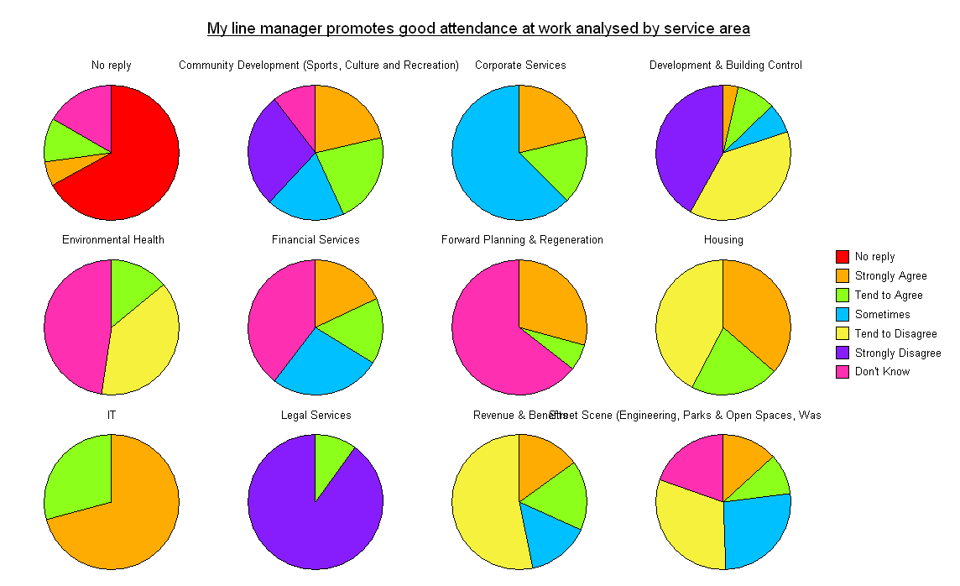
Source: Employee Survey 2006
Pay / Pay Slips
Employees have a very high level of confidence in Ribble Valley’s Payroll Services (see figure 4.3). Over 90% (94.8%) of respondents agree that they will be paid on time and correctly.
When people have a query with their wage/salary 85.2% are happy with the way it is dealt with by Payroll.
The majority of respondents (86.8%) read their payroll attachments, but fewer (35.2%) find them consistently interesting.
Figure 4.3: Pay and Pay Slips

 | Strongly agree | Tend to agree | Some-times | Tend to disagree | Strongly disagree | Don't know
I feel confident my wage/salary will be paid on time and correct | 55.1% | 39.7% | 4.5% | 0.6% | 0.0% | 0.0%
If I have a query with my wage/salary I am happy with the way it is dealt with by Payroll | 41.0% | 44.2% | 5.1% | 0.0% | 0.0% | 9.6%
Source: Employee Survey 2006
FLOW OF INFORMATION
KEY ISSUES
- Most Employees feel that they have sufficient information to do their job properly (only 9% disagree).
- The vast majority of employees (80.2%) feel that at least sometimes they are told how the authority is performing.
- However over 40% of employees (42.3%) feel that communications between service areas is insufficient, with only 16% of staff feeling inter-service area communications are efficient.
- Over a third of respondents (34.6%) feel that communications are better than three years ago.

Information Channels
Figure 5.1: Information and Communication

 | Strongly Agree | Tend to Agree | Some-times | Tend to Disagree | Strongly Disagree | Don't Know
I am given sufficient information to do my job properly | 10.3% | 48.1% | 30.8% | 9.0% | 0.0% | 1.9%
I am told how the authority is performing | 9.0% | 35.3% | 35.9% | 11.5% | 3.2% | 5.1%
The information I receive is easily understood | 6.4% | 51.9% | 34.0% | 3.8% | 1.9% | 1.9%
We have regular staff meetings | 15.4% | 53.8% | 15.4% | 7.1% | 4.5% | 3.2%
I would find it useful to know more about the Council | 7.1% | 29.5% | 38.5% | 17.3% | 1.9% | 4.5%
I am told how I can help the Council succeed | 1.9% | 24.4% | 34.6% | 25.0% | 4.5% | 8.3%
The Council's clearly communicates its Ambitions and Priorities to me. | 7.1% | 30.1% | 42.3% | 14.7% | 3.2% | 2.6%
I hear things first through 'rumours' | 18.6% | 26.3% | 41.7% | 6.4% | 5.8% | 1.3%
There is sufficient communication between service areas | 3.2% | 12.8% | 35.3% | 32.7% | 9.6% | 5.8%
Formal communication channels are efficient | 3.8% | 30.1% | 40.4% | 14.7% | 4.5% | 5.8%
Over the past three years I feel that communication within the Council has improved | 5.1% | 29.5% | 17.9% | 17.9% | 3.2% | 26.3%
I am aware of Ribble Valley’s Equality Strategy | 3.5% | 35.3% | 8.3% | 23.7% | 10.3% | 17.9%
I am aware of the Council’s budget setting process | 10.3% | 28.2% | 7.1% | 27.6% | 11.5% | 14.7%
Source: Employee Survey 2006
The majority of respondents (58.4%) feel that they receive sufficient information to do their job (see figure 5.1 above). This is a significant fall since the 2004 survey where 66.6% of respondents felt they had the right information to help them do their job. The figure was even higher in 2001 (88%).
Only 44.3% of respondents feel that they are reasonably well informed as to how the Council is performing, dropping from nearly 50% of respondents agreeing with the statement in 2004. Employees from different sections (and working in different locations) responded differently to the question. Of the 14.7% that disagreed that they were well informed as to how the Council was performing only 17% did not work at the main Council Offices. Expectations are that the staff based at the offices are more informed regarding performance.
The majority of staff (58.3%) feel that the information they receive is easy to understand as compared to 67.9% in 2004. This rises to over 92% of respondents when including those who stated ‘sometimes’.
Surprisingly few employees (36.6%) show at least some degree of willingness to find out more about Ribble Valley Borough Council compared to 50.9% in 2004. Nearly 20% (19.2%) of respondents actively stated that they had no wish to find out more.
The further employees are away from the Council Offices the more important ‘rumours’ are in devolving information. 78% of respondents that work from the pool or sports centre either strongly agree or tend to agree that they hear things first through rumours, compared to 69% of respondents that work from the depot and 40% of respondents working in the Council Offices. In 2001 66% of respondents answered that they often felt they found out important information about the Council through informal channels.
Figure 5.2: Information Channels and ‘rumours’
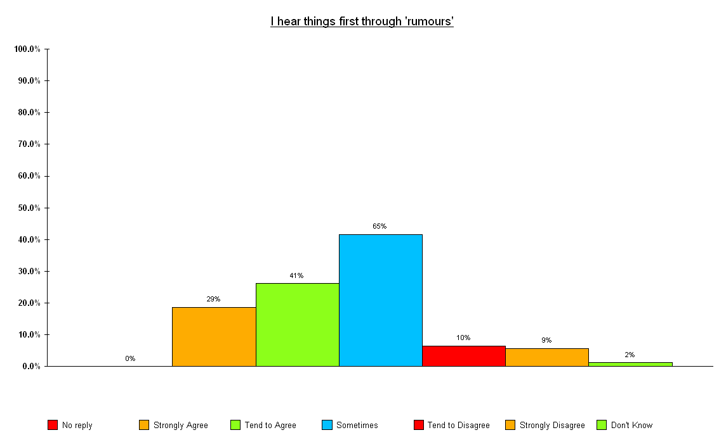
Source: Employee Survey 2006
Nearly 80% (79.5%) of respondents state that the Council at least sometimes communicates its ambitions and priorities to them. Of the 18% (24% in 2004) that disagreed with this nearly half are not based at the main offices.
A key point of concern regarding communication is that a very high proportion of respondents (42.3%) still feel that there is insufficient communication between service areas. This was also the case in 2004. Only 16% of the respondents agree/tend to agree that there is sufficient communication between service areas. A strong perception of “silos” still seems to be apparent.
Respondents are not completely convinced that formal communication channels are operating effectively, with only 33.9% agreeing that they operate effectively and nearly 20% of respondents disagreeing.
Nearly 35% of respondents feel that communication within the Council has improved over the last three years (a rise from 29.6% in 2004) and just over 21% (a fall from 24%) disagreed. (see fig 5.3 below)
Figure 5.3: Improvement in communications over past three years

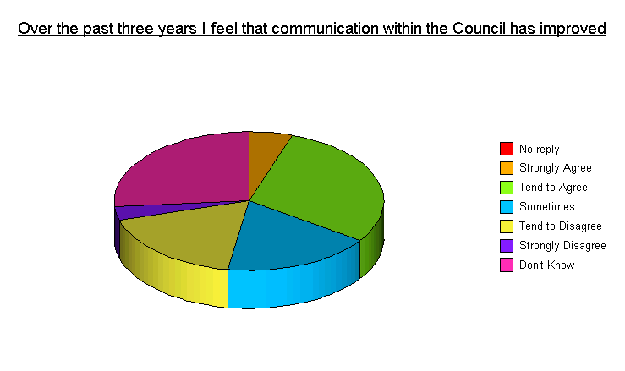
Source: Employee Survey 2006
Nearly 40% (38.8%) are aware of the Council’s Equality Strategy, 34% are not aware of it. Only 15% of those who are unaware of the strategy are based outside of the main offices, 71% are based at the main offices.
39.1% of respondents are not aware of the Council’s budget setting process. 39.2% of respondents from the main office are unaware of the process as are roughly half the respondents based elsewhere.
Staff Newsletter - Backchat
About 90% (89.1%) of respondents read the Council’s Staff Newsletter – Backchat - at least sometimes and over 55.1% find it interesting and informative. Most respondents, (61.5%) agree that the Newsletter provides a good mix of stories. There is very little difference between the results of this survey and the 2004 survey.
Figure 5.4: Readership of the Staff Newsletter

 | Strongly agree | Tend to Agree | Some-times | Tend to Disagree | Strongly Disagree | Don't know
I read most of the Backchat Newsletter | 23.7% | 48.1% | 17.3% | 4.5% | 5.8% | 0.0%
I find Backchat interesting and informative | 14.7% | 40.4% | 26.9% | 10.9% | 5.1% | 1.3%
Backchat has a good mix of Council and human interest stories | 14.1% | 47.4% | 25.6% | 715% | 4.5% | 1.3%
Source: Employee Survey 2006
In the authority's first Internal Communications Survey in 2005, 98% of respondents said they read Backchat at least sometimes, which compared well to the 2004 Employee Satisfaction Survey (90%). Nearly 80% of respondents found the information in Backchat useful, which again compared well with the 2004 Survey (56%). While there is little difference between the responses in the 2004 and 2006 Employee Surveys, the Internal Communications Survey seems to reveal that Backchat has had a positive impact on internal communications and has been warmly received by staff. Further analysis will be available following the authority's 2007 Internal Communications Survey.

Verbatim Responses
The free text verbatim questions, which invited employees to make their own comments and suggestions for improving how Ribble Valley Borough Council works, elicited some responses regarding communication.
In 2004 one quarter of all the literal responses were related to communication issues.
In the 2006 survey only 10% of the responses to ‘If you were Chief Executive for the day what one action would you take to improve the way the council works what would it be?’ were regarding communications.
Many of these comments again relate to better communications being required between service areas and between employees and Senior Management.
Some examples of the comments are given below:
- Strengthen communication between departments and senior management.
- Better communication between different departments.
- Backchat could be more staff based, rather than having articles repeated from the press. More emphasis on staff and what is happening within the departments, updates on what employees have achieved etc…

Customer Focus
KEY ISSUES
- A significant proportion of employees (72.7%) feel that we show a good attitude to customers.
- More than half of all employees feel that opening hours of the council meet the needs of some customers.
- Nearly 40% of employees receive limited amounts of customer feedback with about a further quarter of employees saying they do not receive customer satisfaction data.
- Nearly all employees feel that their customers are satisfied with service they provide at least sometimes.
- 71.8% of employees are aware of Ribble Valley Borough Councils complaints policy.

Customer Focus
A large proportion of respondents (72.7%) feel that people in our organisation show a good attitude to our customers. 72.4% of respondents feel that the quality of the Council's services is good and there has been relatively little change from the 2004 survey and a slightly different worded question in 2001 where 61% felt we provided services valued by the public (see figure 6.1).
Figure 6.1: Customer Focus

 | Strongly agree | Tend to agree | Some-times | Tend to disagree | Strongly disagree | Don't know
The Council emphasises the importance of the customer | 14.7% | 55.8% | 16.7% | 4.5% | 3.2% | 3.8%
Providing high quality service is part of the Council’s culture | 19.2% | 57.7% | 11.5% | 2.6% | 3.2% | 3.8%
I clearly understand what other service areas require of me | 13.5% | 32.7% | 26.3% | 14.7% | 3.2% | 7.1%
People in our organisation show a good attitude towards customers | 19.2% | 53.2% | 17.9% | 5.8% | 0.0% | 1.9%
The quality of the Council's services is good | 16.0% | 56.4% | 20.5% | 2.6% | 1.3% | 1.3%
I am able to change the service I deliver to meet customer needs | 19.2% | 50.6% | 11.5% | 6.4% | 1.9% | 7.1%
The opening hours of the Council's services / buildings suits the needs of all our customers | 11.5% | 41.7% | 23.7% | 8.3% | 4.5% | 9.0%
Source: Employee Survey 2006
In a client focused environment it is pleasing that the proportion of employees who feel that we are client focussed is quite high, showing that we have an environment of good customer care.
Just under 13% feel that the opening hours of the council do not meet the needs of some customers. Over half of all respondents feel that opening hours of the council meet the needs of customers.
Customer Feedback
Over a third of respondents (39.1%) (see figure 6.2) state that they regularly receive feedback on levels of customer satisfaction, this is an improvement on 2004. 27% feel they receive no feedback from their customers.
Figure 6.2 Customer Feedback

 | Strongly agree | Tend to agree | Some-times | Tend to disagree | Strongly disagree | Don't know
I receive feedback on levels of customer satisfaction | 8.3% | 30.8% | 28.2% | 19.9% | 7.1% | 4.5%
Customers are satisfied with the services I deliver | 19.2% | 55.1% | 10.9% | 1.9% | 0.0% | 10.9%
I am aware of our customer complaints policy | 15.4% | 56.4% | 6.4% | 10.3% | 3.2% | 5.8%
Source: Employee Survey 2006
Nearly three quarters of all respondents (74.3%) feel that customers are satisfied with the services they deliver - only 1.9% disagreed.
71.8% of respondents are aware of Ribble Valley Borough Council’s complaints policy (13.5% are unaware); this indicates that maybe some more internal publicity is required.
Change
KEY ISSUES
- A high proportion of employees (62.8%) feel that change is necessary for the Council to continue to improve.
- However, 24.4% feel that there are too many changes
- Nearly half (46.8%) of all employees would like greater involvement in change initiatives
- Nearly 40% of employees do not feel that time is set aside time to look at improving the way we work

Organisational Change
Change appears to be an issue that divides respondents with a significant polarisation of opinion being demonstrated. Most respondents (62.8%)(67.9% in 2004) agree that the Council needs to change in order to improve (only 8.9% disagree). However as figure 7.1 shows 24.4% of respondents felt that there are too many council – wide changes, this rises to 75% of respondents in Legal Services and 35.7% of respondents in Street Scene.
Figure 7.1 Organisational Change
 | Strongly agree | Tend to agree | Some-times | Tend to disagree | Strongly disagree | Don't know
This Council needs to change in order to improve | 20.5% | 42.3% | 20.5% | 8.3% | 0.6% | 6.4%
There are too many Council-wide changes | 4.5% | 19.9% | 28.2% | 24.4% | 2.6% | 17.9%
My line manager does not want change | 3.8% | 6.4% | 13.5% | 44.9% | 17.3% | 11.5%
I would like more opportunities to be involved in change initiatives | 6.4% | 40.4% | 30.1% | 13.5% | 0.6% | 7.1%
I have the opportunity to be involved with changes | 8.3% | 21.2% | 43.6% | 14.1% | 5.8% | 5.1%
Change at work is planned and implemented properly | 5.8% | 17.3% | 38.5% | 22.4% | 8.3% | 6.4%
I do not want any change at work | 3.8% | 5.8% | 16.0% | 44.2% | 21.2% | 5.8%
I understand how my role contributes to the Council’s corporate ambitions and objectives | 14.1% | 43.6% | 21.8% | 9.6% | 4.5% | 5.1%
Source: Employee Survey 2006
62% of respondents do not agree that their manager does not want change. Only 14% of respondents did not want more opportunities to be involved in change. Only 23.1% agree that change is planned and implemented properly. Most people (38.5%) only agree that it is sometimes planned and implemented properly.
The majority of respondents (57.7%) understand how their roles contribute to the Council’s corporate ambitions and objectives, with only 14% disagreeing. Further analysis shows that 25% of the respondents in legal services, 50% of respondents from the pool, 30% of respondents based at Salthill depot, and 50% of the respondents graded at scale 1-6 do not understand how their roles contribute to corporate ambitions and objectives.
Job Related Change
A small minority of respondents (14.1%) think that there are too many unnecessary changes to their job (figure 7.2 below).
Figure 7.2: Change related to job

 | Strongly agree | Tend to agree | Some-times | Tend to disagree | Strongly disagree | Don't know
There are too many unnecessary changes to my job | 3.2% | 10.9% | 22.4% | 50.0% | 8.3% | 3.8%
I am involved in any changes to do with my job | 9.0% | 37.2% | 28.2% | 14.1% | 4.5% | 5.8%
I can usually understand why changes are made | 7.1% | 44.2% | 37.2% | 6.4% | 0.0% | 3.8%
I am encouraged to find better ways of doing things | 10.3% | 51.9% | 23.1% | 9.6% | 2.6% | 0.6%
Time is set aside for review and improvement at work | 5.1% | 17.9% | 30.1% | 26.9% | 12.8% | 5.8%
Source: Employee Survey 2006
Nearly half of respondents (46.2%) feel that they are involved in changes to their job, compared to 34% in 2004. Only 18.6% state that they have not been involved, for manual workers this rises to 25% not feeling involved compared to just 4.8% of Principal Officer grade or above.
The majority of respondents (88.5%) say that at least sometimes they understand why changes are made, with only a minority of employees (6.4%) appearing not to understand why changes are made.
Nearly 40% (39.7%) of respondents do not feel that time is set aside time to look at improving the way we work.

Management Style
KEY ISSUES
- Nearly three quarters (74.3%) of respondents feel that through performance management they know what their key accountabilities are
- 75% of respondents know what their annual objectives are
- Nearly 60% (57.1%) of respondents agree that employee and management relations are usually good

Relationship with Line Manager
Nearly three quarters (74.3%) of respondents feel that through performance management they know what their key accountabilities are. This is a massive increase from 2004 when only just over half of respondents (52.2%) knew their key accountabilities. 75% know what their annual objectives are (in comparison to 60% in 2004) - in each case around 10% of respondents disagreed and a significant minority answered ‘Don’t Know’.
Figure 8.1: Employee Relationship with their Line Manager

 | Strongly agree | Tend to agree | Some-times | Tend to disagree | Strongly disagree | Don't know
Through Performance Management I know what my key accountabilities are | 14.7% | 59.6% | 7.7% | 6.4% | 4.5% | 5.8%
I know what my annual objectives are | 15.4% | 59.6% | 7.7% | 6.4% | 3.8% | 5.8%
My line manager lets me know how I am performing | 15.4% | 42.9% | 20.5% | 11.5% | 7.7% | 1.3%
My line manager appreciates it when I perform well | 16.7% | 45.5% | 15.4% | 11.5% | 4.5% | 5.1%
My line manager is motivational | 13.5% | 37.8% | 25.0% | 15.4% | 5.1% | 1.9%
My line manager acts upon my views and suggestions | 15.4% | 42.3% | 30.8% | 6.4% | 3.8% | 0.6%
My line manager shows me respect and consideration | 26.3% | 48.7% | 15.4% | 4.5% | 3.8% | 0.6%
I receive support and guidance from my line manager | 17.9% | 44.9% | 21.8% | 7.1% | 3.2% | 1.3%
My manager is accessible when I need to see him / her | 25.0% | 46.8% | 17.3% | 4.5% | 3.2% | 0.6%
My line manager has explained Risk Assessments to me | 9.0% | 38.5% | 14.1% | 20.5% | 8.3% | 5.8%
I have regular opportunities to raise issues with my line manager | 22.4% | 46.8% | 17.3% | 8.3% | 1.3% | 2.6%
My line manager provides me with regular feedback on the Council’s performance | 6.4% | 34.6% | 26.9% | 20.5% | 5.8% | 3.8%
Source: Employee Survey 2006
The fact that such a high proportion of respondents are informed in the Performance Management System is very positive and affirms its role in providing clarity for ensuring role focus / objectives for employees.
Line Managers on the whole are regarded as providing support for their teams. 58.3% of respondents feel that their line managers let them know how they are performing, but a significant minority (19.2%) do not feel that they get sufficient feedback.
Most respondents (62.2%) also feel that their line managers appreciate it when they do well, which is an increase of around 10% from 2004.
A significant minority (20.5%) disagree that their line manager is motivational.
Nearly three quarters of respondents agree that there is respect and consideration from their line manager.
Nearly 70% agree that their line manager is accessible and they have the opportunity to raise issues with them.
Only 41% agreed that their line manager provides them with regular feedback on the Council’s performance.
57.7% of respondents agree that their manager acts upon their views and suggestions, in comparison to 42.8% of respondents in 2004.
General Management Issues
Less positive than the individual’s relationship with their line manager is the employees’ perception of Senior Managers. Nearly a quarter (22.4%) disagree that senior managers care about their staff.
Figure 8.2: General Management Issues

 | Strongly agree | Tend to agree | Some-times | Tend to disagree | Strongly disagree | Don't know
Employee / Management relations are usually good | 12.2% | 44.9% | 28.8% | 7.7% | 3.2% | 1.9%
The authority understands when people make a mistake | 8.3% | 47.4% | 25.0% | 6.4% | 2.6% | 9.0%
I am happy with the way in which I am managed | 19.9% | 48.7% | 17.9% | 9.0% | 3.2% | 0.6%
My line manager is an effective team leader | 19.9% | 40.4% | 25.6% | 7.7% | 3.8% | 0.6%
My line manager has the ability to communicate with all staff | 23.7% | 42.9% | 18.6% | 7.1% | 5.1% | 1.3%
I was clearly told what was expected of me when I joined | 17.3% | 49.4% | 9.6% | 12.2% | 2.6% | 7.1%
Senior managers care about their employees | 10.3% | 27.6% | 29.5% | 17.3% | 5.1% | 8.3%
Mutual trust exists between management and employees | 10.7% | 31.4% | 27.7% | 12.6% | 8.2% | 4.4%
Source: Employee Survey 2006
Nearly 60% (57.1%) of respondents agree that employee and management relations are usually good. Nearly 70% (68.6%) are happy with the way they are managed. Over 60% agree that their manager is an effective team leader. Two thirds agree that their manager has the ability to communicate with all staff.
Nearly three quarters of respondents agree that at least sometimes there is mutual trust between employees and managers. This has changed from over 40% of respondents feeling that mutual trust did not exist between managers and employees in 2004.
Whilst the majority of respondents (80.7%) (see figure 8.2 ) feel that at least sometimes the authority understands when people make a mistake, a small minority of employees (9%) indicate that they perceive that the authority does not understand when people make a mistake.
Figure 8.3: Management issues

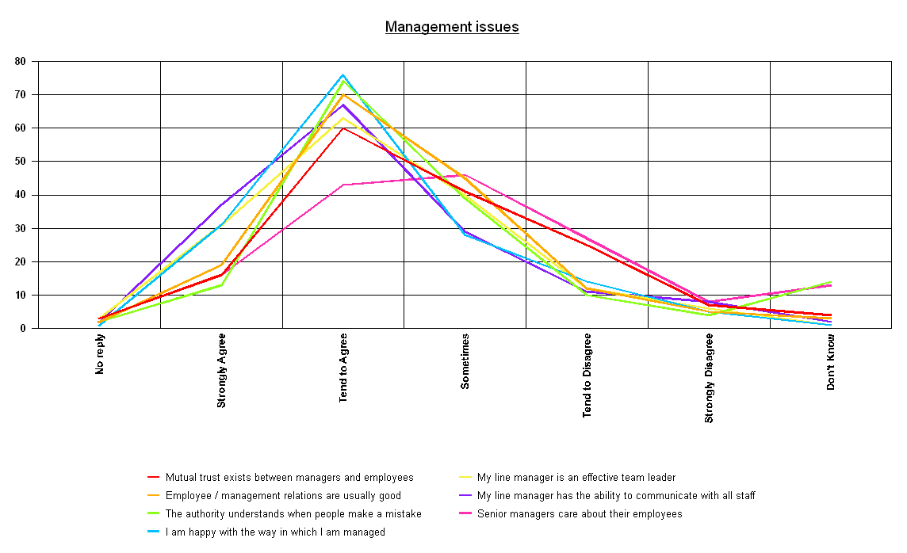
Source: Employee Survey 2006
Verbatim Comments
Management style was an area to elicit a number of verbatim comments which included the following remarks:
- Send managers on team building and motivational training (Note this is not the same as leadership training). If they’re not enthusiastic, how can we be?
- Give more praise to employees so that they feel more valued. This can only improve their performance if they feel valued.

Structures and Services
KEY ISSUES
- 20% of employees understand what each service area provides, compared to over 87% of employees understanding what their own service area provides.
- Only 24.3% of employees feel that the council operates as one big team.
- Only 30.8% of respondents stated that Councillors valued what their service area did.
- 52.6% of respondents understand how they fit into the bigger picture

Service Areas
Nearly 20% of respondents feel they do not understand what each service area does within the council (see figure 9.1)
Figure 9.1: Organisational issues – Service Areas

 | Strongly agree | Tend to agree | Some-times | Tend to disagree | Strongly disagree | Don't know
I understand what each service area does in the Council | 12.2% | 44.2% | 20.5% | 17.9% | 2.6% | 1.9%
Work problems are solved efficiently in my service area | 11.5% | 48.1% | 23.7% | 9.0% | 5.1% | 1.3%
I am aware what services my Service Area provides | 32.7% | 54.5% | 4.5% | 4.5% | 0.6% | 1.9%
I feel that the authority would not want to lose me | 9.6% | 31.4% | 20.5% | 12.2% | 10.9% | 14.7%
The Council works as one big team | 6.4% | 17.9% | 26.9% | 25.6% | 16.7% | 5.8%
The work of my service area is valued by Councillors | 6.4% | 24.4% | 17.3% | 17.3% | 11.5% | 21.8%
Service areas in the Council work well with each other | 4.5% | 22.4% | 40.4% | 16.0% | 5.1% | 10.3%
Employees at different levels in the Council help each other | 9.0% | 35.3% | 35.3% | 7.7% | 3.2% | 9.0%
Source: Employee Survey 2006
Nearly 40% of respondents feel that the authority would not want to lose them, but a large proportion of respondents (23.1%) feel that Ribble Valley Borough Council is ambivalent to their employment.
Only 30.8% of respondents stated that Councillors valued what their service area did, and a significant minority (28.8%) do not feel that Councillors value their service areas work / function.
Only a minority of respondents (24.3%) responded that they felt the council worked as one big team (see figure 9.1). Nearly 45% (42.3%) of all respondents actively feel that we do not work as one team. This is reflected again in another question where only 26.9% of respondents agreed with the statement that service areas in the council work well with each other with a further 40.4% responding that service areas work well together ‘sometimes’.

Organisational Structure
Nearly 45% (42.3%) of respondents agreed that if their service area was organised differently it would be more effective.
Figure 9.2: Organisational structure
 | Strongly agree | Tend to agree | Some-times | Tend to disagree | Strongly disagree | Don't know
If my service area was organised differently we would be more effective | 9.6% | 32.7% | 20.5% | 21.2% | 5.8% | 9.0%
The Council structure is simple and non-bureaucratic | 3.8% | 25.6% | 25.6% | 23.7% | 3.8% | 16.0%
I understand how I fit into the bigger picture | 10.3% | 42.3% | 22.4% | 14.1% | 5.1% | 5.1%
Source: Employee Survey 2006
Nearly 30% (27.5%) of respondents do not agree that the Council structure is simple and non-bureaucratic.
52.6% of respondents understand how they fit into the bigger picture.
Figure 9.3: Perception of organisational structures
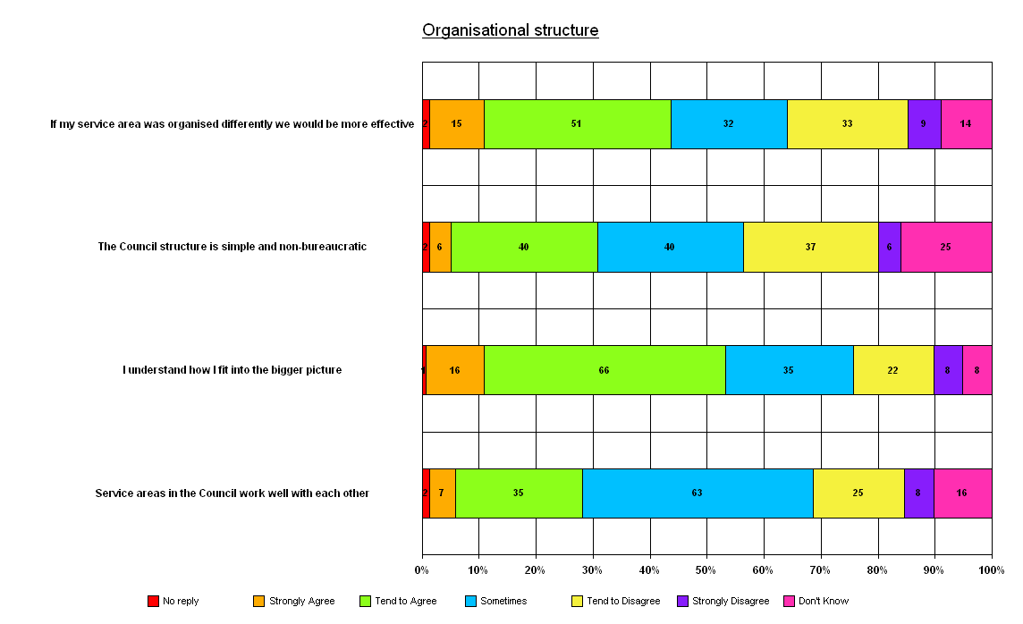
Source: Employee Survey 2006
Training and development
KEY ISSUES
- Most employees are happy with the training they receive.
- 48.8% of employees believe the Council invests in training.
- Most employees believe the Council is equitable in its allocation of training amongst employees.

As figure 10.1 below shows, employees have mostly positive things to say about the training that is offered by Ribble Valley Borough Council to its employees.
Figure 10.1: Training and Development

 | Strongly agree | Tend to agree | Some-times | Tend to disagree | Strongly disagree | Don't know
I am happy with the training I have received | 9.6% | 51.3% | 19.2% | 10.9% | 4.5% | 2.6%
I have had a performance appraisal in the last 12 months | 35.3% | 44.2% | 0.6% | 7.1% | 9.0% | 1.9%
I am happy with the induction training I received | 10.9% | 42.9% | 7.7% | 10.3% | 8.3% | 16.7%
The Council invests in training and development | 13.5% | 35.3% | 28.2% | 9.6% | 2.6% | 9.0%
It is easy to obtain the training I need | 11.5% | 33.3% | 23.1% | 17.9% | 5.8% | 5.8%
Training is not allocated fairly (only available to the few) | 3.2% | 17.9% | 14.7% | 26.9% | 10.9% | 23.1%
I get the training I need to do my job well | 9.6% | 47.4% | 20.5% | 12.8% | 5.1% | 2.6%
I am encouraged to use my own initiative | 29.5% | 55.1% | 6.4% | 5.1% | 1.3% | 0.0%
The workforce is better trained than it used to be | 7.7% | 41.0% | 12.8% | 5.8% | 1.3% | 29.5%
My line manager encourages my training and development | 19.2% | 42.3% | 16.0% | 12.8% | 3.8% | 3.8%
Source: Employee Survey 2006
60.9% of respondents are happy with the training they have received. However 21% felt that training as a whole wasn’t allocated fairly.
Nearly 80% of respondents have had a performance appraisal in the last 12 months, an increase from 2004 when only 58.5% had. It might be expected that some staff that have worked for the authority for less than 12 months haven’t had the opportunity to be appraised. There is still a suggestion that new starters are being appraised as soon as possible whereas long serving staff are not being appraised.
Nearly 20% of respondents were not happy with the induction training they received. 31% of these respondents had worked for the authority for more than 6 years, a further 31% have worked for the authority for 3-5 years. .
Although over 70% (77.5%) of respondents agree that at least sometimes they receive the training required to do their job well.
On a positive note over 80% (84.6%) agree that they are encouraged to use their own initiative. Managers encourage training and development according to 61.5% of respondents.
VERBATIM COMMENTS
The survey asked employees if they were made Chief Executive for the day what one action would they take to improve the way the Council works.
Responses were analysed as below:
- 10.5% of responses related to ‘communications’;
- 24.4% of responses related to service improvements or prioiritisation;
- 14% of responses related to ‘working conditions’ – holiday entitlements, flexi –leave, training or pay;
- 20.9% of responses related to ‘team building’ – including getting to know each other;
- 12.8% of responses related to issues such as the Council building (heating and work environment), Health and safety, risk assessments and quality of equipment;
- 17.4% of responses are classified as ‘other’.
The survey also gave respondents an opportunity to make any other comments – 30.8% of respondents added comments. Some comments could be categorised as above, but the majority were very random in content.
Examples of some of the responses received to the two questions are listed below.
Communications
This has been covered in the ‘Flow of Information’ section.
Service Improvements and Prioritisation
- Review the ambitions and objectives of the Council so they are clearer, more achievable and more relevant to what we are actually doing (planning and housing do not rule the authority)… Re-focus the Council’s direction and put funds where they are genuinely needed most.
- I would take account of what out-lying towns need eg housing, sports facilities, elderly etc…
- Ensure timings of performance appraisals, forward planning for service plans are planned well in advance to ensure best outcomes from staff.
- Close the contact centre, as I don’t believe it has improved our services.
- Reduce the number of committee meetings.
- Instigate business process re-engineering throughout the Council.
Working Conditions
- Money has been invested by the Council to improve machinery and equipment. Why not invest money in paying staff good wages?
- Better chances for self-development (training).
- Make flexible working more flexible…more child-friendly hours.
- Review flexi arrangements to reflect modern working practices.
- Scrap the existing induction system and ensure new starters are induced properly…
- I would arrange for the provision of a crèche for the pre-school children of staff…
- Make sure all staff take part in at least some physical activity each day…a healthier workforce will breed a healthier work environment, less sickness absence, and a more motivated team. Make it compulsory…
Team Building
- Outdoor team building
- Try to bond the staff together…
- Create better links between Councillors and staff. Encourage Councillors to spend a day with staff to understand their service areas better.
- Make departmental/team meetings compulsory in all departments – this would encourage ‘togetherness’ and keep everyone informed of changes and performance
- Encourage Councillors to visit employees in the workplace regularly.
- Encourage short secondments of officers to different sections to broaden the all around appreciation and knowledge.
Working Environment
- Make work environment more comfortable during winter months by ensuring heating works.
- Make sure everyone has correct working equipment to carry out their tasks efficiently…
- Ensure all line managers are held accountable for health and safety of staff…
- Never had a risk assessment when I have worked here for over 10 years…
Other
- Have a female perspective on Management Team.
- The DSO staff do not feel welcome at the annual Christmas drinks with the mayor and are not made welcome by Directors, managers or the Chief executive.
- Some members of staff do not have current contracts of employment. Performance appraisals should be professionally done, management are paying li service to it. Monthly meetings regarding risk assessment should be done.
- In order to encourage people to take part in the survey there should be a random prize draw.
- I cannot recall any worthwhile staff developments as a result of the last survey, so I don’t expect any improvements in staff conditions etc from this one either!
- The Intranet is not used as much as it should be…
- I like working for the Council it’s been a family to me and they look after their staff.
- It is very hard to keep motivated when the future is uncertain.
- This is a good place to work and staff are, as a rule, friendly and co-operative.
- I have thoroughly enjoyed taking part in this survey!
- Ribble Valley is a very good council to work for.

Recommendations and issues arising from the research
The recommendations and ideas for the way forward outlined in this section of the report do not provide the definitive solution for all the issues raised in this research, rather they are a ‘starter for 10’ and stimuli for further discussion by Senior Managers and Members.

Issue | Potential Actions | Responsibility of | To be done by | Link to Corporate Ambitions and Priorities
1) Low response rates to the survey by some employees | - Ask Service Manager / Line Manager to encourage employees to participate | - HR Manager  - Service Managers  - Corporate Policy Officer | Next survey to be carried out 2008.
2) Lack of information about other Service Areas | - Improve Service Area information on Intranet (see Accountancy pages as good eg)  - Produce short service area profiles for Induction.  - Hold refresher inductions for employees after five years | - Service Managers  - Personnel | Ongoing
6) Stress | - Continue with the planned work on stress management and investigate ways to minimise the problem amongst staff (i.e. subsidised relaxation classes etc)  - Consider carrying out the ‘Stress Survey’ as run in Pendle and Hyndburn. | - Personnel  - Corporate Policy Officer | April 2008
7) Perception of staff not being valued | - Adopt a positive approach to staff recognition and encourage a culture where all staff receive acknowledgement for ‘jobs well done’, and where staff can feel valued. | - Personnel | Ongoing
11) Perceived lack of support from Senior Managers | - Ensure that messages from senior staff are effectively disseminated by line managers  - Ensure senior managers are visible | - CMT  - Service Managers | Ongoing

