RIBBLE VALLEY BOROUGH COUNCIL
INFORMATION
REPORT TO POLICY & FINANCE COMMITTEE
Agenda Item No
meeting date: 30 JANUARY 2007
title: REVENUES AND BENEFITS GENERAL REPORT
submitted by: DIRECTOR OF FINANCE
principal author: MARK EDMONDSON

1 PURPOSE

  - To inform committee of debts outstanding for business rates, council tax and sundry debtors. Also to update committee on the Benefits Performance, Benefits Fraud investigations, Prosecutions and Sanctions.

1.2 Relevance to the Council’s ambitions and priorities:
- Council Ambitions/Community Objectives/Corporate Priorities
Without the revenue collected from rates, council tax and sundry debtors we would be unable to meet the Council’s ambitions, objectives and priorities.

2 NATIONAL NON-DOMESTIC RATES (NNDR)

2.1 The following is a collection statement to 17 January 2007:

 | £000 | £000 |  | % | 2005/06  %
Balance Outstanding 1 April 2006 |  | 164
Charges | 11,725
Plus costs | 4
Transitional surcharge | 34
Write ons | 69
 | 11,832
Less
- Transitional relief | -312
- Exemptions | -524
- Charity, Rural, Former Agricultural Discretionary Relief | -603
- Small Business Rate Relief | -478
- Write offs | -136
 | -2,053 | 9,779
 |  | 9,943 |  | 100.0
Less Cash Received |  | -8,950 |  | 90 | 88.4
Amount Outstanding |  | 993 |  | 10

NB Information above relates to all years, but BVPI 10 is concerned only with collection of 2006/07 debt. On this measure our current collection in year at 31/12/06 is 88.6% compared to 87% at 31/12/05.

3 COUNCIL TAX

3.1 The following is a collection statement for the council tax to 17 January 2007:

 | £000 | £000 |  | % | 2005/06  %
Balance Outstanding 1 April 2006 |  | 393
Charges | 32,270
Plus costs | 48
Transitional relief | 2
Write ons | 20
 | 32,340
Less - Exemptions | -722
- Discounts | -2,469
- Disabled banding reduction | -37
- Council Tax Benefit | -1,790
- Write offs | -11
 | 5,029 | 27,311
 |  | 27,704 |  | 100%
Less Cash Received |  | -24,593 |  | 88.8 | 88.5
Amount Outstanding |  | 3,111 |  | 11.2

NB Information above relates to all years, but BVPI 9 is concerned only with collection of 2006/07 debt. On this measure our collection rate at 31/12/06 is 87.9% compared to 87.8% at 31/12/05.

4 COUNCIL TAX CUSTOMER SATISFACTION SURVEY

4.1 In accordance with the Revenues and Benefits Service Plan 2006/07 I have conducted a customer satisfaction survey for visits to the Council Tax and Business Rates enquiry counter. Attached at Annex 1 is a copy of the report, which details the excellent results achieved by the Revenues Section. No amendments or improvements to the service have been identified.

5 SUNDRY DEBTORS

5.1 A summary of the sundry debtors account at 6/11/2006 is:

 | £000 | %
Amount Outstanding 1 April 2006 | 304
Invoices Raised | 861
 | 1,165 | 100
Less Paid | -783 | 67
Total Outstanding | 382 | 33

Aged Debtors | 000s | %
< 30 days | 86 | 22
30 - 59 days | 49 | 13
60 - 89 days | 10 | 2
90 - 119 days | 2 | 1
120+ days | 235 | 62
 | 382 | 100

5 HOUSING BENEFIT – PERFORMANCE

  - Each quarter the Department of Works and Pensions (DWP) provide all Council’s with information on their Housing Benefit Administration performance compared against DWP targets and all other authorities.

I attach a summary (annex 2) showing our performance for the period 1st October – 31st December 2006. You will see in every category our score is comfortably in the highest Grade, which is Grade 4.

- HOUSING BENEFITS FRAUD

  - BVPI 76C

The following is summary of fraud investigation for the period 1st October 2006 to 31st December 2006.

Completed fraud investigations
 | 2006/07
Q1 | 49
Total | 49

Average caseload (YTD)
2006/2007 | 2456

Number of investigations per 1000 caseload
2006/2007 | 49/2467 | 19.95

7 BVPI 76D

7.1 The following is a summary of fraud prosecutions and sanctions for the period 1st October 2006 to 31st December 2006.

2006/2007 | Q1
Cautions
Administrative penalties
Successful prosecutions | 1
Accepted prosecutions | 1
Total | 2

Average caseload (YTD)
2006/2007 | 2456

Number of prosecutions/sanctions per 1000 caseload
2006/2007 | 2/2467 | 0.8143

7.2 Ribble Valley Borough Council has brought the following prosecutions for benefit fraud over the last three months:

i) Living together – Joint case with the Department for Work and Pensions (DWP). Summons issued and awaiting prosecution.
ii) Living together – Joint case with the Department for Work and Pensions (DWP). Successful Prosecution - 40 hours community service given.
8 FUTURE
8.1 January 2007 will see the Benefit section being involved with the National Fraud Initiative (NFI), which is overseen by the Audit Commission. The NFI do electronic data matching techniques to highlight discrepancies with Housing Benefit data by cross-referencing data from different databases. It is expected that these data matches will highlight discrepancies needing investigation.

4 CONCLUSION

  - We continue making excellent progress in collecting these debts.

  - The performance of our Housing Benefit Section when compared to others is excellent.

REVENUES AND BENEFITS MANAGER

PF4-07/MHS/AC
18 JANUARY 2007
Annex 1

Ribble Valley Borough Council
Council Tax and Business Rates
Customer Satisfaction Survey
Report November 2006

Background and Methodology
Background
In line with the Revenues and Benefits Service Plan Action Plan for 2006/2007 a Council Tax and Business Rates Customer Satisfaction Survey was conducted during September and October 2006. The survey was built around similar questions asked in the 2006/2007 Best Value Benefits Satisfaction Survey. Other local authorities’ surveys were also examined in order to develop the survey.
The questionnaire was designed using the SNAP software procured as part of the East Lancashire e-Partnership. This made analysis of the results faster. The key issues explored in the research were:
- Customer experience during a visit to the offices
- Customer experience of dealing with staff
- Customer experience of forms filled in
- Overall response to query
Aims and Objectives of Research
The research will provide:
- Contextual information to be used in the continual development of the service.
- Employee feedback on customer satisfaction
- Contextual information to feed in to future Best Value and CPA reviews.
Methodology
As previously mentioned a self-completion questionnaire methodology was employed in this research with the SNAP survey software being used to analyse responses.
The staff answering queries at the Council Tax and Business Rates office made a note of all visitors to the office over the period of one month. 160 people were selected to take part in the survey.
Response Rates
The overall response rate was low at 32%. The decision was taken by the Revenues and Benefits Manager not to send out a reminder letter.

headline Results
As illustrated by the chart below, the majority of visits to the Council Tax/Business Rates Office were for Council Tax Billing enquiries (78%). Council Tax Recovery enquiries and Business Rates Billing enquiries accounted for 10% of the visits each, and 4% of those who completed the questionnaire gave no reason for their visit.

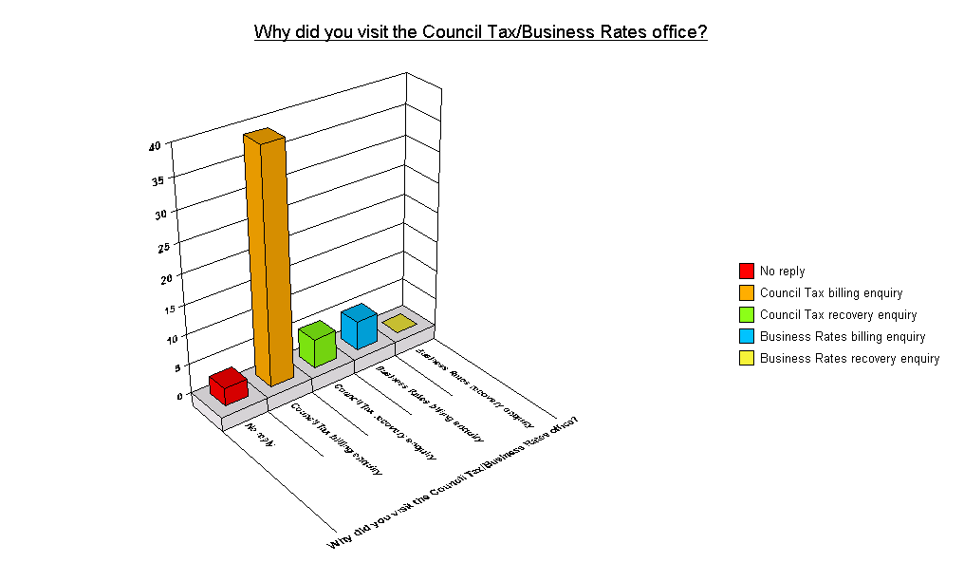

About Your Visit

Q2 | About your visit. Please state how strongly you agree or disagree with the following
 |  | Strongly agree | Agree | Neither agree or disagree | Disagree | Strongly disagree | Does not apply/don't know | No reply
 | The office is somewhere that is easy to get to | 35.3% | 54.9% | 7.8% | 0.0% | 0.0% | 0.0% | 2.0%
 | The opening hours of the office are convenient for me | 19.6% | 62.7% | 7.8% | 5.9% | 2.0% | 0.0% | 2.0%
 | I did not have to wait a long time before I was dealt with | 41.2% | 51.0% | 2.0% | 2.0% | 2.0% | 0.0% | 2.0%
 | The office was ‘clean and tidy’ | 41.2% | 54.9% | 2.0% | 0.0% | 0.0% | 0.0% | 2.0%
 | Overall, I am satisfied with the ways in which I can contact the local authority Council Tax/Business Rates section | 33.3% | 52.9% | 9.8% | 0.0% | 0.0% | 0.0% | 3.9%

- 90.2% of respondents found the offices easy to get to
- 82.3% agreed that the opening hours were convenient
- 90.2% of respondents agreed (40% strongly) that they didn’t have to wait long to be seen
- just 4% strongly disagreed/disagreed that they didn’t have to wait long to be seen
- 96.1% thought that the offices were clean and tidy
- 86.2% are satisfied overall with the ways in which they can contact the council

The Person Who Dealt With You

Q3 | About the person who dealt with you. Please state how strongly you agree or disagree with the following
 |  | Strongly agree | Agree | Neither agree or disagree | Disagree | Strongly disagree | Does not apply/don't know | No reply
 | They were smart and presentable | 41.2% | 49.0% | 5.9% | 0.0% | 0.0% | 0.0% | 3.9%
 | They were polite and helpful | 43.1% | 47.1% | 3.9% | 0.0% | 2.0% | 0.0% | 3.9%
 | They were able to deal with my request | 45.1% | 45.1% | 5.9% | 0.0% | 0.0% | 0.0% | 3.9%
 | I understood what they told me | 41.2% | 47.1% | 3.9% | 0.0% | 2.0% | 0.0% | 5.9%
 | Overall, I am satisfied with how I was dealt with | 39.2% | 49.0% | 2.0% | 0.0% | 2.0% | 2.0% | 5.9%

- 90.2% strongly agreed/agreed that staff were smart and presentable
- 90.2% agreed that staff were polite and helpful
- 90.2% agreed that staff were able to deal with their request
- 88.3% agreed that they understood the information that staff told them
- 88.2% agreed that they were satisfied with the way in which they were dealt

Completion of Forms

Q4 | During your visit to the Council Tax office you may have been asked to complete some forms. Please answer the following questions based on these forms and state how strongly you agree or disagree with the following
 |  | Strongly agree | Agree | Neither agree or disagree | Disagree | Strongly disagree | Does not apply/don't know | No reply
 | The forms were easy to fill in | 3.9% | 43.1% | 3.9% | 2.0% | 0.0% | 29.4% | 17.6%
 | I could fill in the forms quickly | 5.9% | 35.3% | 9.8% | 2.0% | 0.0% | 27.5% | 19.6%
 | If necessary I could get help completing the forms | 5.9% | 35.3% | 5.9% | 0.0% | 0.0% | 33.3% | 19.6%
 | Overall I am satisfied with the forms that I needed to complete | 9.8% | 41.2% | 5.9% | 0.0% | 0.0% | 27.5% | 17.6%

- 47% agreed that the forms were easy to fill in; 2% disagreed with this
- 41.2% agreed that they could fill in the forms quickly; 2% disagreed with this
- 41.2% agreed that they could get any help they needed in filling out the forms
- overall, 51% were satisfied with the forms they were asked to complete (0% disagreed)

Response Received

Q5 | About the response you got. Please state how strongly you agree or disagree with the following:
 |  | Strongly agree | Agree | Neither agree or disagree | Disagree | Strongly disagree | Does not apply/don't know | No reply
 | The reason that I visited the office has been resolved satisfactorily | 45.1% | 37.3% | 3.9% | 0.0% | 0.0% | 7.8% | 5.9%
 | My enquiry has been dealt with quickly | 37.3% | 47.1% | 3.9% | 0.0% | 0.0% | 3.9% | 7.8%
 | My bill was clear and easy to understand | 25.5% | 43.1% | 2.0% | 0.0% | 2.0% | 9.8% | 17.6%
 | Overall I am satisfied with the response that I got | 27.5% | 54.9% | 5.9% | 0.0% | 0.0% | 2.0% | 9.8%

- 82.4% agreed that their reason for visiting the office was resolved satisfactorily
- 84.4% agreed that their enquiry was dealt with quickly
- 68.6% agreed that their bill was clear and easy to understand; 2% strongly disagreed
- 82.4% were satisfied overall

Further Analysis
Age
As shown in the chart below, the majority of visitors were aged 65+ (36%). Those aged between 30 and 50 and those between 50 and 65 accounted for 24% of the visits each. Visitors aged 18-30 accounted for 14% of respondents.
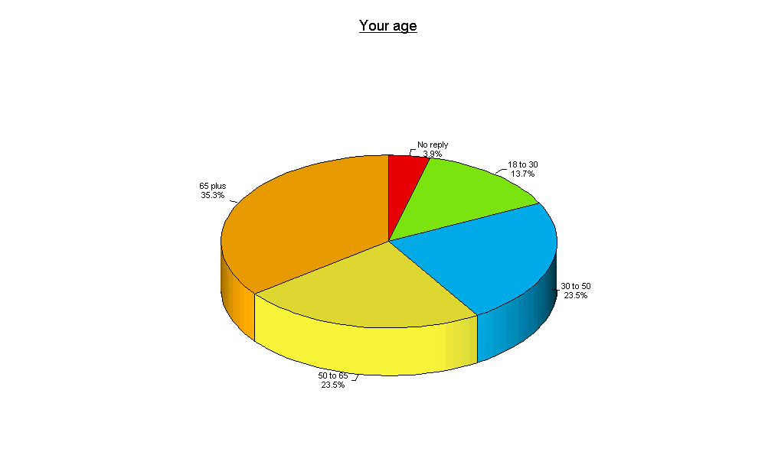

gender
The chart below shows that nearly 53% of visitors were female, 41% male and 6% didn’t reply.
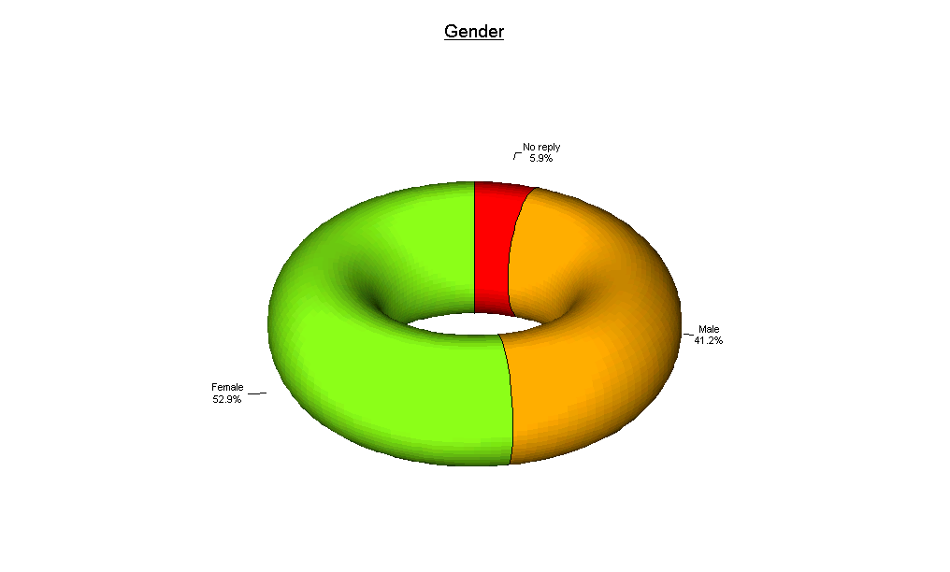

Reasons for Visiting

 | 65+ | 50 - 65 | 30 - 50 | 18 – 30
Council Tax Billing | 83% | 67% | 75% | 86%
Council Tax Recovery | 6% | 8% | 17% | 14%
Business Rates Billing | 11% | 17% | 8% | 0%

As shown in the table, the most popular reason for visiting the office is Council Tax Billing enquiry – this is universal across all age groups.

The Office is Easy to Get to

As outlined earlier, the majority of visitors to the offices are aged 65+. When asked whether they found the offices easy to get to, 100% of those aged 65+ responded positively. This is in comparison with 83% of 50-65 year olds, 92% of 30-50 year olds, and 86% of 18-30 year olds. Although the 18-30 age group should be the most physically mobile of all, less found it easy to get to the offices. This could be accounted for by restraints on their time (similarly for the 50-65 bracket), and also due to the fact that people in this age group are more likely to be accompanied by young children, and, as commented by one respondent, the offices are not easily accessible with a pram or pushchair.

Opening Hours

Overall, 82% of respondents agreed that the opening hours were convenient. 100% of all over-65s agreed, as did 83% of 50-65s, 75% of 30-50s and 57% of 18-30 year olds. The percentage of those who agree that the office opening hours are convenient reduces proportionally with the age of the respondents. This is likely to be due to those under the age of 65 being more likely to be in full time employment. Also, the younger the respondent, the more likely they are to have a young family, and therefore have less free time. Overall, 8% of respondents disagreed with the statement regarding opening hours – this 8% consisted of 25% of all 30-50 year olds and 8% of all 50-65 year olds. 43% of 18-30 year olds had no strong opinion on the matter, as did 8% of 50-65 year olds.

Ways to Contact the Council

Overall, 88% were satisfied with ways to contact the council. This can be broken down across the age groups as follows:

Q2e | Overall, I am satisfied with the ways in which I can contact the local authority Council Tax/Business Rates section:
 |  | Strongly agree | Agree | Neither agree or disagree | Disagree | Strongly disagree | Does not apply/don't know | No reply
 | Under 18 | 0.0% | 0.0% | 0.0% | 0.0% | 0.0% | 0.0% | 0.0%
 | 18-30 | 42.9% | 42.9% | 14.3% | 0.0% | 0.0% | 0.0% | 0.0%
 | 30-50 | 33.3% | 50.0% | 16.7% | 0.0% | 0.0% | 0.0% | 0.0%
 | 50-65 | 33.3% | 50.0% | 8.3% | 0.0% | 0.0% | 0.0% | 8.3%
 | 65+ | 27.8% | 66.7% | 5.6% | 0.0% | 0.0% | 0.0% | 0.0%

Encouragingly, no respondents disagreed with the given statement, and only 10% had no strong feelings on the matter.

Perceptions of the Staff

Were staff smart and presentable?
 | Strongly agree | Agree | Neither agree nor disagree | Disagree | Strongly disagree | Don’t know/Does not apply | No reply
Council Tax Billing enquiry | 41.0% | 48.7% | 7.7% | 0.0% | 0.0% | 0.0% | 0.0%
Council Tax Recovery enquiry | 0.0% | 100% | 0.0% | 0.0% | 0.0% | 0.0% | 0.0%
Business Rates Billing enquiry | 80.0% | 20.0% | 0.0% | 0.0% | 0.0% | 0.0% | 0.0%
Business Rates Recovery enquiry | 0.0% | 0.0% | 0.0% | 0.0% | 0.0% | 0.0% | 0.0%

Only 7.7% of respondents visiting Council Tax Billing enquiry staff didn’t agree that the staff were smart and presentable. All other respondents agreed that staff were smart and presentable.

Were staff polite and helpful?
 | Strongly agree | Agree | Neither agree nor disagree | Disagree | Strongly disagree | Don’t know/Does not apply | No reply
Council Tax Billing enquiry | 41.0% | 51.3% | 2.6% | 0.0% | 2.6% | 0.0% | 2.6%
Council Tax Recovery enquiry | 20.0% | 60.0% | 20.0% | 0.0% | 0.0% | 0.0% | 0.0%
Business Rates Billing enquiry | 80.0% | 20.0% | 0.0% | 0.0% | 0.0% | 0.0% | 0.0%
Business Rates Recovery enquiry | 0.0% | 0.0% | 0.0% | 0.0% | 0.0% | 0.0% | 0.0%

- 95.3% of the people visiting Council Tax Billing enquiry staff agreed that they were polite and helpful
- 80.0% of the people visiting Council Tax Recovery enquiry staff agreed that they were polite and helpful
- 100% of the people visiting Business Rates Billing enquiry staff agreed that they were polite and helpful

Were staff able to deal with your request?
 | Strongly agree | Agree | Neither agree nor disagree | Disagree | Strongly disagree | Don’t know/Does not apply | No reply
Council Tax Billing enquiry | 43.6% | 48.7% | 5.1% | 0.0% | 0.0% | 0.0% | 2.6%
Council Tax Recovery enquiry | 40.0% | 60.0% | 0.0% | 0.0% | 0.0% | 0.0% | 0.0%
Business Rates Billing enquiry | 80.0% | 20.0% | 0.0% | 0.0% | 0.0% | 0.0% | 0.0%
Business Rates Recovery enquiry | 0.0% | 0.0% | 0.0% | 0.0% | 0.0% | 0.0% | 0.0%

Only 5.1% of visitors to Council Tax Billing enquiry staff didn’t agree that staff were able to deal with their request. All other respondents agreed.

Did you understand what they told you?
 | Strongly agree | Agree | Neither agree nor disagree | Disagree | Strongly disagree | Don’t know/Does not apply | No reply
Council Tax Billing enquiry | 41.0% | 48.7% | 2.6% | 0.0% | 2.6% | 0.0% | 5.1%
Council Tax Recovery enquiry | 20.0% | 80.0% | 0.0% | 0.0% | 0.0% | 0.0% | 0.0%
Business Rates Billing enquiry | 80.0% | 20.0% | 0.0% | 0.0% | 0.0% | 0.0% | 0.0%
Business Rates Recovery enquiry | 0.0% | 0.0% | 0.0% | 0.0% | 0.0% | 0.0% | 0.0%

Only 2.6% of visitors to Council Tax Billing enquiry staff disagreed that they did not understand what they were told. 2.6% neither agreed nor disagreed. All other respondents agreed that they understood what they were told.

Overall, were you satisfied with they way you were dealt with?
 | Strongly agree | Agree | Neither agree nor disagree | Disagree | Strongly disagree | Don’t know/Does not apply | No reply
Council Tax Billing enquiry | 41.0% | 48.7% | 2.6% | 0.0% | 2.6% | 0.0% | 5.1%
Council Tax Recovery enquiry | 20.0% | 80.0% | 0.0% | 0.0% | 0.0% | 0.0% | 0.0%
Business Rates Billing enquiry | 60.0% | 20.0% | 0.0% | 0.0% | 0.0% | 20.0% | 0.0%
Business Rates Recovery enquiry | 0.0% | 0.0% | 0.0% | 0.0% | 0.0% | 0.0% | 0.0%

Only 2.6% of visitors to Council Tax Billing enquiry staff disagreed that they were satisfied with the way they were dealt with. 2.6% neither agreed nor disagreed. 20% didn’t know or felt it did not apply. All other respondents agreed that they were satisfied with the way they were dealt with.

Forms

Overall, 48% agreed that the forms were easy to fill in. This can be broken down across the ages as follows:

Q2e | The forms were easy to fill in:
 |  | Strongly agree | Agree | Neither agree or disagree | Disagree | Strongly disagree | Does not apply/don't know | No reply
 | Under 18 | 0.0% | 0.0% | 0.0% | 0.0% | 0.0% | 0.0% | 0.0%
 | 18-30 | 0.0% | 42.9% | 14.3% | 14.3% | 0.0% | 28.6% | 0.0%
 | 30-50 | 0.0% | 33.3% | 0.0% | 0.0% | 0.0% | 50.0% | 16.7%
 | 50-65 | 8.3% | 50.0% | 0.0% | 0.0% | 0.0% | 16.7% | 25.0%
 | 65+ | 5.6% | 50.0% | 5.6% | 0.0% | 0.0% | 27.8% | 11.1%

These may initially appear to be low percentages, however, 30% of all respondents replied ‘Don’t know/Not applicable’, and a further 16% gave no reply. Only 2% disagreed and these were from the 18-30 years old age group where they represented 14.3% of respondents.

A further 42% agreed that they could fill in the forms quickly. Again, these percentages may initially appear to be quite low, however, 28% responded ‘Don’t know/Not applicable’, 20% gave no reply, and 10% had no strong feelings on the subject. 2% disagreed.

VERBATIM COMMENTS
Respondents were asked ‘Is there anything else you would like to add?’ The listed below are the verbatim comments received:
- I am 90 and still driving so the office is a place I can get to at present. I live at Whalley so this might be a problem in the future.
- With one final settlement bill, the money was taken via direct debit (OK). The other was under £1 (60p) and could not be. With the admin for me to pay this, and you to receive it, it would be better written off!
- It would be nice to have a sample copy of forms because they do get confusing.
- I only went to the tax office about how much council tax had been paid. Everyone was helpful.
- Didn't know my children had left home several years ago! Should have known from electoral register
- I like the new automatic doors.
- Satisfied.
- In general the 'Benefits Team' give a good service.
- I am very grateful for the help I've had with my Council Tax. I hope others in difficulty get the same result. Thank you.
- I feel that access into the council building is not ideal for prams, and taking the lift is a bit out of the way, I feel a ramp would be more suitable.
- My daughter who lives at the same address actually visited your offices on my behalf and has completed the questionnaire/survey.
- I find it hard to understand on having a paying in counter with three paying areas only ever having one open resulting in unnecessary queues.
- I found it pleasure to enter office and very helpful indeed and was the staff.
- I find Ribble Valley very good to deal with.
- Good service received. Thank you.
- Good help from staff.
- I would like to say when I have dealt with staff over the phone my enquiry has been dealt with politely and quickly. The staff made everything clear.
- Thank you for being understanding when I explained my circumstances. It has been a bad year health and financial wise. I was scared to come and see you but when I left I felt a big weight off my mind.
- I am not interested in the office side of the matter but I would like to mention the poverty stricken state of the village of Wilpshire, no road sweeping, blocked drains, never cleaned out, a poor service I think for the amount of council tax we pay. I would also be interested in how much of the council tax is left after the expense of the special van and the 2 men sat there week in week out. A better way would be to send with the new rate paper 10 pre-paid envelopes, although you might not agree as it should be about saving public money.

Report authors:

Michelle Haworth Rebecca Midgley
Corporate Policy Officer Assistant Corporate Policy Officer
Annex 2

Performance Measures for Housing/Council Tax Benefits 2006/2007

 | Grade ranges
Performance Measure | 1 | 2 | 3 | 4 | RVBC
PM1: Average number of days taken to process new claim for HB/CTB | Over 48 days | 48-37 days | 36-30 days | Under 30 days | 20
PM2: Percentage of new claims outstanding over 50 days | Over 26% | 26-17% | 16-9% | Under 9% | 1.62%
PM3: Percentage of new claims decided within 14 days of receiving all information | Under 73% | 73-82% | 83-90% | Over 90% | 98%
PM4: Percentage of rent allowance claims paid on time or within 7 days of decision being made | Under 73% | 73-82% | 83-90% | Over 90% | 97%
PM5: Average number of days taken to process a notification of a change of circumstances | Over 28 days | 28 – 21 days | 20-9 days | Under 9 days | 5 days
PM6: Percentage of cases for which the calculation of the amount of benefit due is correct | Under 96% | 96-97% | 98-99% | Over 99% | 100%

