DECISION
RIBBLE VALLEY BOROUGH COUNCIL
REPORT TO POLICY AND FINANCE
COMMITTEE
Agenda Item No.

meeting date: | 26 September 2006
title: | Comprehensive Performance Assessment 2006
submitted by: | Chief Executive
principal author: | Michelle Haworth – Corporate Policy Officer

- PURPOSE
  - To outline the new approach to Comprehensive Performance Assessment (CPA) as developed by the Audit Commission and published in July 2006.
  - To seek approval for submitting a request for re-categorisation.
- Relevance to the Council’s ambitions and priorities:
- Council Ambitions:
The Comprehensive Performance Assessment report is the key document produced at the end of the CPA process. It impacts strongly on our Ambitions, Priorities and Future Plans and is therefore very important. An improvement plan is developed out of the findings of the inspectors.
- Community Objectives:
- Corporate Priorities:
- Other Considerations:
- BACKGROUND
  - Since September 2005, the Audit Commission has consulted widely on options for district council CPA from 2006 and proposals for the framework. This has included regional events for a wide range of local authorities, regular discussion with a reference group of district councils and meetings with a number of stakeholders, including government departments. Over a hundred responses to the recent formal consultation exercise were also included. Overall, the Audit Commission says there has been a high level of engagement and a consensus about the way ahead.
  - The new arrangements will run from 2006 to March 2009.
- OUTLINE DETAILS OF THE CHANGES TO THE APPROACH TO CPA
  - CPA re-categorisation for district councils will follow a two-stage approach:
- to decide whether or not there is sufficient evidence of a potential category change; and if so
- to undertake a corporate assessment to determine if a category change is warranted.
  - It is recognised that this approach provides an effective use of resources for both the Audit Commission and councils. Therefore, from 2006, the Audit Commission will only undertake re-categorisation activity in the following circumstances:
- where a council requests re-categorisation and is able to demonstrate significant evidence of improvement; or
- where the Commission identifies evidence of significant deterioration.
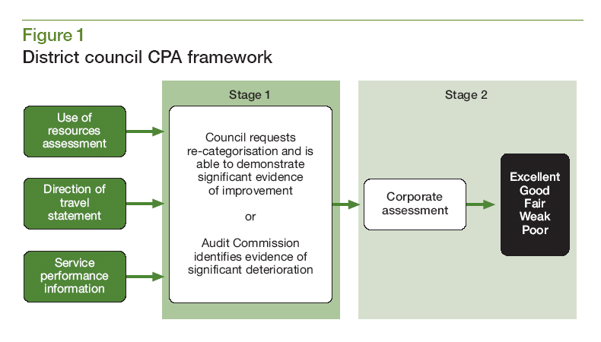
  - The Audit Commission has decided that from 2006 all district councils will continue to receive an annual use of resources assessment and a direction of travel statement.
Use of Resources
  - The next use of resources assessment in district councils will follow a similar timescale as for the 2005 assessment and will be reported in March 2007. The subsequent assessment will be based on the 2006/07 financial year and the Audit Commission will then bring forward the reporting of judgements to December 2007.
  - In 2005 all councils submitted a self-assessment for the value for money theme. From 2006 councils will only be required to submit a new self-assessment if they scored a 1 for the value for money theme in the previous year.
Direction of Travel Statement
  - In September 2005, direction of travel statements were introduced for district councils. These statements were designed to recognise progress achieved since the last CPA categorisation.
  - In 2005/06, district councils received an unscored summary commentary for inclusion in the annual audit and inspection letter, on the council’s overall progress in delivering its improvement priorities since CPA categorisation. The Audit Commission intends to maintain this approach to direction of travel.
Service Performance Information
  - The Audit Commission has produced a tool which sets out performance information, for each district council, improvement and current performance on an agreed set of PIs (see summary at Appendix A). The tool will subsequently be updated annually in January when new audited PI information becomes available.
  - The Audit Commissions consultation exercise showed that there is broad support for this principle of analysing service performance with the proposal to use this to inform the decision about the need for re-categorisation and shows a move to concentrate more on the standard of service provison.
  - Service performance information will include:
- analysis of performance indicators; and
- inspection scores – both those undertaken by the Commission and by the BFI.
  - The Audit Commission will present and analyse service performance information in a clear and consistent way but it will not be scored. The significance given to the analysis of service performance information in determining whether sufficient improvement or deterioration has taken place to warrant a new corporate assessment will depend on the circumstances of the council. For example, service improvement is likely to feature more prominently if service performance was an area of weakness in the last corporate assessment. This will be considered alongside other evidence to get a rounded picture of improvement or deterioration in each council.
  - District councils will be able to use other robust performance information as part of the evidence they wish to be considered if making a case for re-categorisation. For example, it is recognised that councils may wish to use reliable local performance indicators to demonstrate progress against their local priorities.
  - When deciding whether to carry out a new corporate assessment, the Audit Commission will consider the following evidence from the analysis of service performance information:
- the extent of improvement – what proportion of the PIs in the set are improving;
- the strength of improvement – whether improvement seen at the individual PI level is significant or better than expected; and
- the areas of improvement – whether improvement is seen in areas of previously weak performance or areas of local priority.
  - Except for user survey data, they will use 2002/03 as the baseline year from which to assess whether significant improvement or deterioration has taken place. Quartiles will be used to distinguish how current performance compares with that of other councils.
Corporate Assessment
  - The Audit Commission will plan and deliver a programme of corporate assessments between 2007 and 2009. There will be a number of opportunities for councils to request re-categorisation throughout this period. Councils should work closely with their relationship managers in deciding if and when to apply for a corporate assessment. Early discussion with relationship managers is recommended.
  - It will not be necessary for councils to undertake a self-assessment at this stage in the process. Instead, all councils will be sent a copy of the PI tool to assist in assessing service improvement. They will then be given the opportunity to submit a brief statement (a maximum of three sides of A4) outlining the improvements, which they have made since the original CPA and signposting supporting evidence. As well as the council’s statement, key sources of evidence will include: those listed above (Use of Resources, Direction of Travel, etc) and any other relevant evidence of improvement or deterioration such as robust local PIs. The Audit Commission will also invite written evidence from a limited number of key stakeholders including:
- Audit Commission lead housing inspector;
- Government Office/Lead Official;
- BFI; and appointed auditor (when not the same as the relationship manager).
  - The key decision on whether or not a corporate assessment will be undertaken will be made by regionally coordinated panels. Each panel will involve a council peer representative and out-of-region Commission involvement to ensure consistency and transparency. The panels will also consider those cases where there is evidence of deterioration.
  - The test the panels will apply is whether there is a realistic prospect of a change in category if the corporate assessment is carried out. This will apply in the following circumstances:
- where councils can demonstrate performance that is significantly better than that identified in the original corporate assessment, and the council wishes to be considered for re-categorisation; or
- where there is evidence of significant deterioration in either service or corporate performance which could result in re-categorisation if a further corporate assessment was undertaken.
  - Self-assessment will remain the starting point for corporate assessment. In preparing self-assessments, councils will be asked to expand on the brief statement outlining their improvement to address current performance and cover the Key Lines of Enquiry (KLOE). Councils will be given six weeks to prepare their self-assessments
  - The corporate assessment methodology has been streamlined to make it more proportionate and will include:
- five corporate assessment themes instead of ten;
- direct involvement of a council peer in the assessment process; and
- a web-based stakeholder survey (as currently used in corporate assessment for single tier and county councils. This involves a web-based survey of key partners within the locality to ascertain their views of the council, reducing the need for extensive interviews and written evidence)
  - It will not include diagnostic assessments of service areas. The Audit Commission will not introduce a harder test into re-categorisation activity. The categories will remain the same and corporate assessment broadly similar, to ensure comparability between the 2003/04 categories and those determined from 2006 onwards.
Key questions and themes
  - The Key Lines Of Enquiry (KLOE) have been updated and streamlined but map directly across to the original KLOE used for corporate assessment in 2003/04. The key questions and themes are set out below.
  - The self-assessment will be used by councils to explain their achievements in the context of their locally determined priorities. However, as before, councils will be expected to demonstrate that they have focused on an appropriate balance between local and national priorities.
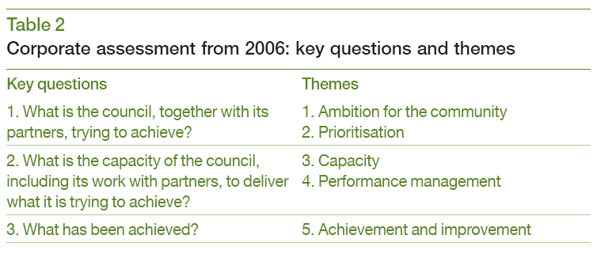
Scoring
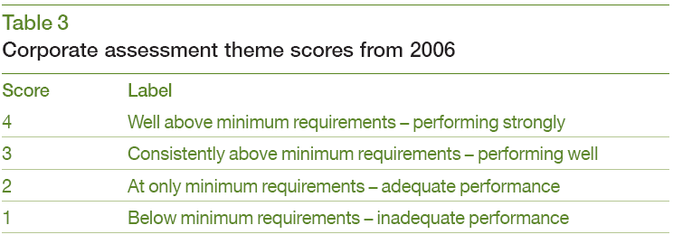
  - As there are now five themes instead of ten, the theme weightings have been adjusted accordingly. This is based on mapping the previous KLOE to the new ones. All the new theme scores will be multiplied by a weighting factor, to align them with the original themes, so that they form approximately the same proportion of the overall score. The weighting for the new themes is as follows:
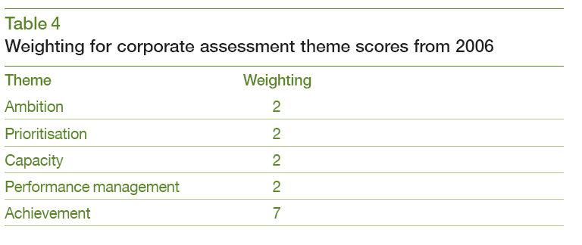
  - As not all district councils will undergo a re-assessment, the same CPA categories will apply to ensure comparability with the 2003/04 assessments. Bandings will apply.
- Excellent 45 – 60
- Good 36 – 44
- Fair 28 – 35
- Weak 21 – 27
- Poor 20 or less
Timing and priorities for corporate assessment activity
  - The Audit Commission will develop a rolling programme of corporate assessments which will be updated at regular intervals. In order to give councils advance notice of when they will be able to request re-categorisation, Table 1 below sets out a series of submission dates, together with details of their links to the audited PIs and Annual Audit and Inspection letters that will be taken into account.
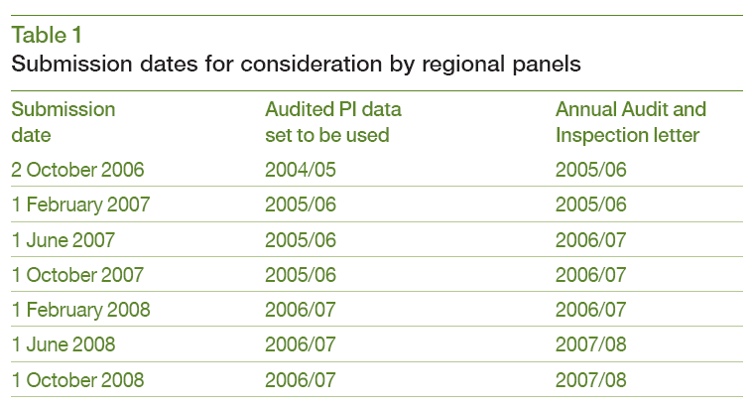
  - The Audit Commission will aim to notify councils of the outcome of their requests within six weeks of the submission date. Councils will be given three months’ notice of intention to undertake a corporate assessment.
  - The detailed programming of those councils prioritised for re-assessment will depend on factors such as:
- proximity to next category boundary in 2003/04 assessment;
- length of time since the last published CPA category; and
- strength of evidence for re-categorisation.

- Summary
  - The Director of Finance is reasonably confident that we will receive a better Use of Resources judgment, as reported in the Annual Audit and Inspection letter, for 2006/07. The current Performance Information tool is based on 2004/05 audited data. A quick comparison has been carried out on the PI’s in this set to determine their performance for 2005/06. We are reasonably sure that the Performance Information tool produced for 2005/06 will show similarly good results as the 2004/05 tool.
  - When presented with this information Corporate Management Team were in agreement that if we applied for re-categorisation the earliest date we would be interested in would be 1 June 2007 based on the evidence that would be used. This date would also give the council plenty of time for preparation.
What would this involve?
  - A brief statement outlining our case for re-categortisation would be submitted on 1 June 2007.
  - The Panel would decide whether there is enough evidence to show improvement and therefore whether the council be allowed to submit a corporate self assessment. The Audit Commission will aim to notify councils of the outcome of their requests within six weeks of the submission date (13 July 2007).
  - Councils will be given three months’ notice of intention to undertake a corporate assessment. Therefore, if approved, a corporate self assessment would need to be submitted and inspection would then follow.
- RISK ASSESSMENT

- Resources: None
- Technical, Environmental and Legal: None
- Political: None
- Reputation: The reputation of the council can only improve if we succeed in being re-categorised as ‘good.’
- it is recommended that committee
  - On the basis of the information provided should make the decision of when, if at all, the Council should apply for a Comprehensive Performance Assessment re-categorisation. It is recommended to committee that this date should be 1 June 2007.

Michelle Haworth
Corporate Policy Officer

For further information please ask for Michelle Haworth, extension 4421

