RIBBLE VALLEY BOROUGH COUNCIL

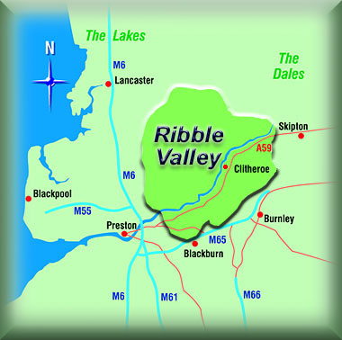

DRAFT
Waste Awareness and Education Strategy
2009

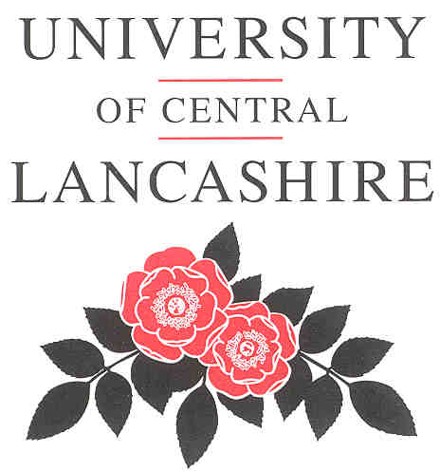

CONTENTS

Page

1.0 Introduction 3

2.0 Aims of the Strategy 3 - 4

- Review of Strategy actions and achievements
to date 5 - 8

- Current and future recycling activities within
Ribble Valley 9 - 10

- Proposed Waste Awareness and Education
Campaigns and initiatives 11 - 13

6.0 Conclusions 14

7.0 Appendices 15 - 16
Appendix 1: Recycling coverage within the Ribble Valley

1.0 Introduction

1.1 Ribble Valley Borough Council has for some time recognised the
importance of raising public awareness on waste issues and the need for education to change public behaviour and attitude by encouraging increased participation in waste minimisation, recycling and composting initiatives.

1.2 Members also agreed that adopting a waste awareness and education strategy would clearly indicate their commitment to raising public awareness on waste. Additionally it was considered that such a Strategy would provide an ideal educational framework leading to consistency of information and identify more practical activities that can be undertaken by not just the Council but by everyone.

1.3 The first Waste Education and Awareness Strategy was originally prepared by the University of Central Lancashire and presented the observations and findings of the author.

1.4 The Strategy was adopted by Ribble Valley Borough Council, Community Committee in May 2004.

1.5 Ribble Valley must continue to promote reuse, recycling, composting and waste minimisation if it is to achieve the challenging targets set under national and European legislation. These targets include those set by the National Waste Strategy 2000, and the European Landfill Directive. These targets have been incorporated within Lancashire’s revised Municipal Waste Management Strategy “Rubbish to Resources.”

1.6 Such legislation has been introduced for a number of reasons, including to reduce the volume of biodegradable municipal solid waste entering landfill. Under Article 5 of the Landfill Directive, a target has been set to reduce the volume of biodegradable municipal solid waste entering landfill to 35 per cent of the 1995 level by 2020. Other aims of the Landfill Directive include banning liquid waste, highly flammable waste and tyres from entering landfill.

2.0 Aims and objectives of the Strategy
2.1 Aims:
- reduce waste growth;
- increase and maintain participation in recycling and composting schemes within the Ribble Valley;
- raise and maintain awareness of waste issues;
- promote the Waste Hierarchy – reduce, reuse, recycle;
- provide a diverse range of ways of increasing education and awareness within the Borough;
- give a message that is consistent;
- link in with regional and national campaigns;
- take into account a wide range of audiences, including householders, school children/ students, teachers, community and voluntary groups, Council employees, politicians and local businesses;
- be specific to the unique nature of Ribble Valley and its population.
2.2 Objectives:
Strategy | Objective | Action
Community Strategy | Promote waste minimization and reduction through recycling and reducing waste generation | Undertake campaigns and action on waste minimization, reduction and recycling by assessing recycling rates
Corporate communications Strategy  2007 - 2009 | We will communicate clearly and openly with customers, staff and partners, in order to facilitate mutual understanding and the delivery of high-quality, efficient and cost effective services | Raise awareness of the authority`s role as a community leader  Improve relationships with partners and stakeholders  Ensure communications are accurate, honest, understandable and timely  Enhance the authority`s reputation  Improve the authority`s use of communications technology  Listen to the views of residents, staff and councilors
Corporate Performance and Improvement Plan | Promote waste minimization and reduction through recycling and reducing waste generation | Work with the public, local companies and practice throughout the Borough.
Corporate Performance and Improvement Plan |  | Re-using materials whenever possible rather than throwing them away.
Corporate Performance and Improvement Plan |  | Reducing the amount of waste we generate and help others to reduce their waste too
Corporate Performance and Improvement Plan |  | Working together to expand current recycling initiatives.
Corporate Performance and Improvement Plan |  | Expanding as far as possible our composting activities.
Citizens Charter | The Council will provide high quality, affordable and responsive public services that develop the social and economic well being of the Borough whilst safeguarding the rural nature of the area | The document sets service standards for :  Emptying of bins  Kerbside collection of recyclables  Local recycling centres

3.0 Review of actions and achievements to date
3.1 In previous years, Ribble Valley has done much to promote environmental education and awareness. The success of such schemes is evident from the increase in recycling and composting rates that have been achieved.

3.2 The recycling rate for Ribble Valley has more than doubled since 2004/05 from 18.54% to 37.87% achieved in 2008/09.

3.3 Total waste arising have also continued to reduce during this period and is currently down 6% on 2004/05 arisings which is against the national trend which has seen a growth in waste produced.

  - The original Strategy included a number of proposals to encourage participation by businesses, schools and the public. These proposals were achieved as follows.
3.5 Provide information to householder:

3.5.1 Communication with residents during the various phases of rolling out the three stream wheeled bin refuse and recycling collection service has been achieved using the following techniques;

3.5.2 In July 2005 Community Committee determined their preferred method for three stream collection. They also instructed officers to carry out a consultation exercise to establish the public views on the proposed container based system and also to provide information that would assist in identifying the types of containers most suited to the different property type. A questionnaire was used for the consultation exercise.The outcome of the consultation was that over 87% felt that the questionnaire explained the need to make changes clearly. 78% agreed to the proposed changes to a container based system with 72% also agreeing to the choice of containers.

    - Trial round – Changes to the service was first highlighted within the Councils Ribble Valley News paper distributed to every household within the authority.

    - Householders in the target round were then sent a written letter advising them on the timetable for the delivery of their wheeled bins and a date for the commencement of the new service.

3.5.5 An information pack was issued to every property during the delivery of the wheeled bins. The information pack contained a highly visible envelope containing an introductory letter, a list of frequently asked questions, 3 waterproof address labels and a calendar of collection dates that also detailed information of what materials were acceptable or not acceptable for each wheeled bin.

    - Community Committee were regularly presented with reports seeking decisions on operational policies and/or providing brief updates on the new scheme.

    - Urban Mines, a charity specialising in resource management was employed to carry out an opinion survey of residents on the trial round. The results of the survey showed that 97% were satisfied with the service with 73% rating it better than before. 89% of residents surveyed were satisfied with the information provided.

    - Prior to the roll out of wheeled bins to the remainder of properties within the borough, householders in a significant number of properties were sent location plans and letters explaining the change in collection point. The letter explained the change in policy relating to the point of collection and advised that they would be expected to present the wheeled bins at these locations in future.

3.5.8 As the trial was rolled out in two final phases, the information pack was on both occasions amended to take account on suggestions from a variety of stakeholders leading to the latest calendar as shown in figures 1 and 2 below.

Fig. 1

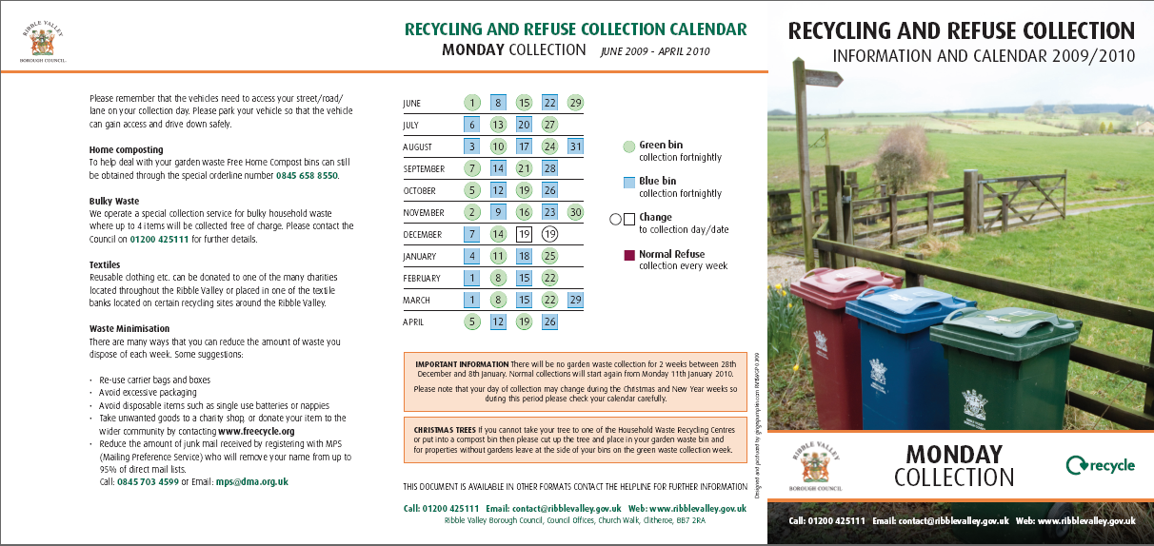

Fig. 2

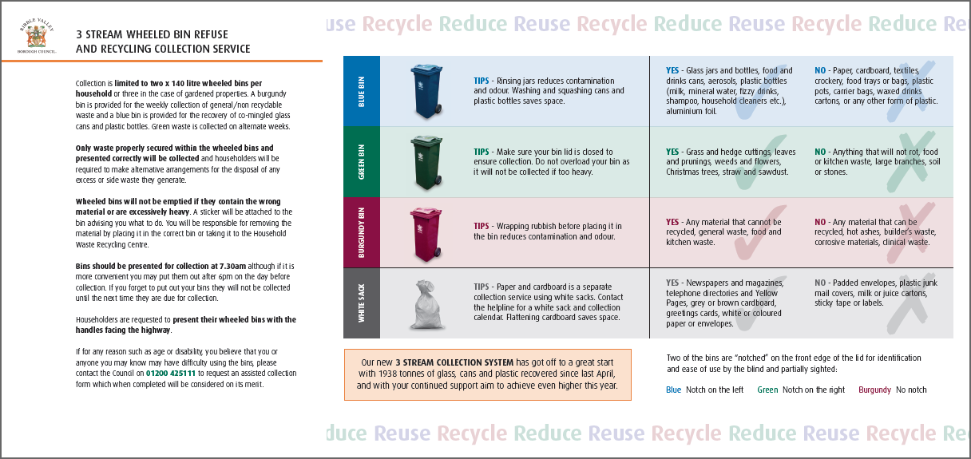

3.6 Introduce a ‘doorstepping’ programme, whereby the doors of households are knocked on to encourage participation;

3.6.1 Random doorstepping is only effective when participation rates are low throughout the authority and is reflected with poor performance levels.

3.6.2 As the Council`s recycling performance levels are meeting predicted targets doorstepping can be more effective by concentrating on problem areas. It was always intended using the identification chips fitted to the wheeled bins to monitor participation rates throughout the authority and takes steps to address areas with low/poor support.

3.7 Make further improvements to Ribble Valley Borough Council’s website;

3.7.1 The Ribble Valley web site is currently being redesigned, and the navigation through the web site is being improved. This should allow easier access to relevant information. The experiences gained over the last few years is helping us to present more detailed and up-to-date information in a manner that can be easily understood. The new web site is intended to be operational by September 2009. The pages relating to waste management/recycling etc do need updating to reflect the changes to the services and facilities offered.

3.8 Improve environmental education in schools;
3.8.1 Presentations are regularly given to local schools and groups (e.g. cubs, scouts and brownies) to encourage waste minimisation, re-use and recycling. During these talks, the waste hierarchy is promoted, and more recently have included more information relating to the 3 stream collection service. These presentations include visual aids such as a CD of pictures showing both the collection vehicles and the Waste Transfer Station at Salthill depot. Other organisations specialising in environmental education or use innovative tools such as `the rapping robot`. A dedicated environmental education team is employed by Lancashire County Councils, new waste treatment contractor (Global Renewables) who have developed an education programme for all schools within Lancashire with whom we work in partnership.
All schools have been offered the fortnightly collection of mixed paper and cardboard with a significant number taking advantage of the free service.

3.8.2 Use of recycled stationary displaying the recycling message, such as pencils made out of paper are still being distributed to schools, voluntary groups etc to promote waste awareness.

3.9 Introduce a Green Office Action Plan at the Council offices;

3.9.1 Waste paper and cardboard recycling facilities are available throughout the council building.

3.9.2 Containers have been provided in the canteen for the recovery of glass, cans, plastic bottles; and batteries.

3.9.3 Procurement exercises have seen improvements in the use of recycled products such as copier paper.

3.9.4 We are continuing to explore other areas where waste can be prevented/minimised, and where recycled products can be either recovered for recycling or purchased.

3.10 Continue with the campaigns implanted to date.

3.10.1 The Council newsletter “Ribble Valley News” is distributed to all households within the Borough and regularly contains information and articles on our waste management services.

3.10.2 Public Events such as The Royal Lancashire Agricultural Society Show
RVBC had a display stand at the Royal Lancashire Agricultural Society Show. This was comprised of posters and displays to raise education and awareness about waste issues within the Borough. A range of materials were given away including leaflets, pencils and mouse mats. A performance was also put on by a theatrical group in order to promote the benefits of composting.

    - Home Composting is still promoted and the free home compost bin offer is still available. Statistics have shown that the take up by Ribble Valley householders is the highest in Lancashire.

3.10.4 Lancashire County Council Nappy scheme is still promoted within the authority.

- Current and future recycling activities within Ribble Valley

4.1 The current system of waste management is comprised of three stream kerbside collection, mixed paper and cardboard collection, Bring Sites and Household Waste Recycling Centres (also known as civic amenity sites). The locations that are served by these facilities are given in Appendix 1 (pages 15 - 16). These waste management systems have allowed Ribble Valley to go a considerable way in ensuring compliance with national and European legislation.

4.2 The waste collection system in Ribble Valley has undergone significant changes during recent years with wheeled bins now the standard containers used in place of the traditional black sack. Over 96.5% of households within the Ribble Valley are currently covered by this system with the remainder on lilac sacks. Households have been provided with two x 140 litre wheeled bins or 3 for properties with gardens. Using split bodied collection vehicles, the burgundy bin used for general/residual waste is collected weekly alongside the alternate weekly collection of a blue wheeled bin for the recovery of co-mingled glass, cans and plastic bottles and a green wheeled bin for garden waste.

4.3 The closure of the local landfill site in Clitheroe has led to the building of a Waste Transfer Station within the Councils depot at Salthill Industrial Estate, Clitheroe. All material collected through the Councils refuse and recycling collection service and street cleansing service is taken to this facility from where the different waste streams are then loaded into bulk haulage containers and transported to the appropriate market/treatment facilities.

4.4 The waste paper collection service has also seen significant improvements to the service. The service has been extended to become available to all households within the Ribble Valley and cardboard is now accepted for collection. These changes are advertised in the paper/cardboard collection calendar and also within the three stream collection calendar which are distributed to every householders annually.

4.5 Legislation such as the Waste Electronic and Electrical Equipment Directive and the Hazardous Waste Directive has resulted in the separate recovery and treatment of larger white domestic items such as fridges, freezers and more recently all white goods, televisions, computers etc. However studies have identified that large percentages of bulky household items can be recovered for reuse and/or recycling. The findings from a recent study into the possibilities for reusing/recycling bulky household waste in Ribble Valley indicated that although the items were generally of a higher quality than normal there was little local demand for used items.

4.6 There are 21 bring sites located on car parks, supermarkets and similar areas within the Ribble Valley where individuals can take their waste for recycling. One of the not so surprising outcomes of the introduction of the three stream collection system is that tonnage of glass and cans from these sites has reduced significantly. Therefore a review of bring sites is to be undertaken to take account of the impact of the kerbside collection systems and other material opportunities.

4.7 There are three Household Waste Recycling Centres (HWRCs) within the Ribble Valley, provide by Lancashire County Council Disposal Authority and operated under contract. The County Council is also to review the HWRCs to consider their location, layout and service provision to be sure that this network compliments the segregated kerbside collections.

4.8 Trials are currently being undertaken to measure the effectiveness of on street recycling bins. The purpose of these bins is to encourage the public to segregate and recycle their litter in the same manner as they do their waste at home.

4.9 Since 1997, Ribble Valley Borough Council has worked in partnership with all local authorities in Lancashire to produce a municipal waste management strategy for Lancashire ` A greener Strategy for a Greener Future`. This Strategy established the policies that would guide the development of waste management in Lancashire for the next 20 years and would set the Partnership at the forefront of waste management performance in this country.. The Strategy also established a mechanism for achieving challenging waste minimisation and recycling targets by the introduction of segregated collection systems and the development of waste treatment facilities for the recovery of waste through recycling and composting.

    - The Strategy has recently been reviewed to cover the period 2008 to 2020 and re-titled `Rubbish to Resources`. It looks to build on the considerable achievements made by the Partnership in delivering its aims. `Rubbish to Resources` represents a step change in how society view rubbish as a resource to be valued and used and not simply to be thrown away. In order to drive up the challenging recycling rates local authorities will need to consider recovery of other material from the domestic waste stream for treatment /recycling and these may include:

a) Textiles

b) Other plastics

c) Food Waste

One of the key targets is to reduce and stabilise waste to 0% growth each year. It is intended to achieve this by awareness raising in order to increase participation in waste initiatives and schemes across all sectors. National and Regional campaigns will be used to help lend strength to local waste management messages. Education programmes are to be delivered to both primary and secondary school children through the Environmental Education Centre located at the Leyland Waste Technology Park. This facility will enable every primary schoolchild in Lancashire to experience the facility through interactive displays and extensive educational resources as well as a tour of the technology as it treats the waste.

    - Enforcement is we believe the last resort and should only apply when householders deliberately contaminate the segregated waste streams and/or ignore specific instructions from the Council.

5.0 Proposed Waste Awareness and Education campaigns and initiatives
  - Ribble Valley Web Site
    - As mentioned earlier in the document the Ribble Valley web site is currently being redesigned, and the navigation through the web site is being improved. We feel that the web site is the key tool at our disposal and it is vital that we ensure that the home pages on waste management are up to date, accurate contain useful features and are more interactive. The site should continue to provide links to other relevant websites, an updated list of frequently asked questions and both the public and commercial waste recycling directories. Other features to be considered for the futureinclude:

a) Useful tips
b) Pages hit counter
c) Feedback forms
d) pictures, graphs, animations

  - 3 stream collection calendars

    - The 3 stream collection calendar has been amended prior to each yearly distribution to take account of feedback from stakeholders and to incorporate changes to the system or provide clearer instructions to the householder. Consideration will be given in future to further improving the information contained within the calendar.

  - Doorstepping/enforcement

5.3.1 Review participation rates and investigate where there appears to be a lower put out of blue and green recycling bins and target properties in such areas with further information or visit where appropriate. Work closely with the collection crews to identify properties where they are not using the wheeled bins as required and take appropriate steps to remedy the problem..

5.4 School programmes
5.4.1 Environmental education is provided to children in schools through the National Curriculum. This can be complemented by further educating children through a number of other means including: -

a) Presentations - Continue to work with all schools within the Ribble Valley to raise awareness on the waste issues.

b) Provide visual aids and the use of recycled stationary.

c) Work with other organisations and educational groups to provide programmes for our local schools.

d) Encourage schools to become involved in interactive education programmes such as provided by Global Renewables, Going for Green etc.

e) Encourage schools to take advantage of environmental initiatives in operation such as achieving Green Flag status.

f) Run competitions relating to waste.

g) Provide acceptable material to schools that compliments and supports their environmental curriculum.

5.5 Promotions

    - Ensure environmental and waste issues are featured regularly in the Ribble Valley New, through the local media and in Parish Council newsletters.
    - Investigate other promotional opportunities.

    - Promote environmental campaigns and environmental organisations such as Mailing Preference Service / Reusable nappies / Free cycle / Aerosol recycling / Tetra Pak recycling.

    - Develop initiatives for yearly campaigns such as recycle week , compost week, real nappy week.

    - Review promotional materials:

a) Stationary
b) Literature
c) Photographs
d) CDs
e)Games
f) Competitions

  - On street recycling bins
5.6.1 Investigate further opportunities to integrate street recycling bins into our services.
  - Vehicle signage

5.7.1 Explore opportunities to attach promotional signs to Council vehicles.

  - Home composting

    - Continue to promote the benefits of home composting.

    - Work with the Councils green waste composting contractor to promote composting through events such as ` Big Heaps` where householders can obtain compost produced from material they have generated.

  - Partnership Working

5.9.1 Work with outside organisations and groups in raising awareness and providing educational support.

5.10 Waste minimisation and recycling of school and community waste

5.10.1 Continue to promote and encourage waste miminisation and recycling of school and community waste.

5.11 Waste minimisation and recycling of business waste

5.11.1 Continue to promote and encourage local businesses to reduce and recycle the waste they produce.

  - Council Strategies
5.12.1 When reviewing its Strategies the Council should ensure that when appropriate, proper consideration should be given to raising public awareness of waste minimisation and recycling issues.

6.0 CONCLUSIONS

6.1 The introduction of the three stream collection system and inclusion of cardboard for collection with waste paper has led to a significant increase in its recycling and composting performance rates. Indeed, Ribble Valley currently has a recycling and composting rate of over 37 per cent and over the last few years has seen a annual reduction in the total waste arisings. Although it could be said that we are fortunate to have an extremely educated population credit should be given to the quality of information issued to householders throughout the whole process of introducing changes to the service.

6.2 We should not be complacent to think that the changes we have introduced have made such an influence on public attitude to waste that it can be maintained without any further effort. Indeed evidence is available to prove that we must constantly raise awareness and encourage continued participation to at least maintain the level of recycling performance that we have achieved.

6.3 In order to ensure that challenging recycling, reuse, composting and waste minimisation targets set under County, national and European legislation are met, Ribble Valley needs to maintain the level of achievement and continue to strive for further improvement. Vital to this is to identify through the Waste Awareness and Education Strategy a programme of activities to raise public awareness on waste issues leading to increased participation rates.

7.0 APPENDICIES
APPENDIX 1: Recycling in Ribble Valley.

TOWN / VILLAGE | KERBSIDE COLLECTIONS |  | RECYCLING CENTRES
TOWN / VILLAGE | 3 Stream | Paper  cardboard | Glass | Paper | Cans | Textiles | Shoes
CLITHEROE  Sainsbury`s Car Park  Booth`s Car Park  Edisford Road Car Park  Mitchell Street Car Park  North Street Car Park | √ | √ | √  √  √  √  √ |  | √  √  √  √ | √  √  √  √  √ | √  √  √  √  √
LONGRIDGE  Safeway Car Park  Spar Car Park | √ | √ | √  √ |  |  | √  √ | √  √
WHALLEY  Rendezvous Nightclub | √ | √ | √ |  | √
BALDERSTONE | √ | √
BARROW | √ | √
BASHALL EAVES | √ | √
BILLINGTON | √ | √
BOLTON-BY-BOWLAND  Main Street Car Park | √ | √ | √ | √ | √ | √ | √
BOWLAND WITH LEAGRAM | √ | √
CHATBURN  Pendle Hotel Car Park | √ | √ | √
CHAIGLEY | √ | √
CHIPPING  Village Hall Car Park | √ | √ | √ |  | √ |  | √
CLAYTON-LE-DALE | √ | √
DINCKLEY | √ | √
DOWNHAM  Village Hall Car Park | √ | √ | √ | √ | √ | √ | √
DUNSOP BRIDGE  Main Street Car Park | √ | √ | √ |  | √ | √ | √
DUTTON | √ | √
EASINGTON | √ | √
GISBURN  White Bull Car Park | √ | √ | √ |  | √
GREAT MITTON | √ | √
GRINDLETON | √ | √
HORTON | √ | √
HOTHERSALL | √ | √
HURST GREEN | √ | √
KNOWLE GREEN | √ | √
LANGHO | √ | √
LITTLE MITTON | √ | √
MEARLEY | √ | √
MELLOR | √ | √
MELLOR BROOK | √ | √
MIDDOP | √ | √
NEWSHOLME | √ | √
NEWTON  Parkers Arms Car Park | √ | √ | √
OLD LANGHO | √ | √
OSBALDESTON | √ | √
PAYTHORNE | √ | √
PENDLETON  Pendleton Car Park | √ | √ | √ |  | √ |  | √
RAMSGREAVE | √ | √
READ | √ | √
RIBCHESTER  Ribchester Car Park | √ | √ | √ |  |  | √ | √
RIMINGTON | √ | √
SABDEN  Sabden Car Park | √ | √ | √ |  |  |  | √
SALESBURY | √ | √
SAWLEY  Spread Eagle Car Park | √ | √ | √
SIMONSTONE | √ | √
SLAIDBURN  Slaidburn Car Park | √ | √ | √ | √ | √ | √ | √
STONYHURST | √ | √
THORNLEY WITH WHEATLEY | √ | √
TOSSIDE | √ | √
TWISTON | √ | √
WADDINGTON | √ | √
WEST BRADFORD | √ | √
WHITEWELL | √ | √
WILPSHIRE | √ | √
WISWELL | √ | √
WORSTON  Calf`s Head Car Park | √ | √ | √ |  | √ |  | √

LANCASHIRE COUNTY COUNCIL HOUSEHOLD WASTE RECYCLING CENTRES

LOCATION | Glass | Paper / Card | Cans | Textiles | Oil | Metal | Green  waste | Fridges /  Freezers | Rubble
Henthorn Road, Clitheroe | √ | √ | √ | √ | √ | √ | √ | √ | √
Chapel Hill, Longridge | √ | √ | √ |  | √ | √ | √ | √ | √
Petre Arms, Langho | √ | √ | √ | √ | √ | √ | √ | √ | √

Hours of opening at all the HWRCs – 08.00 – 19.00 hrs (Every day of the week)

NOTE: Ribble Valley Borough Council provides a free collection service for Bulky household waste Telephone 01200 425111.

