LOCAL FAILURE OF THE RIVERSIDE PATH
THE PARK, WADDINGTON ROAD, CLITHEROE

Introduction
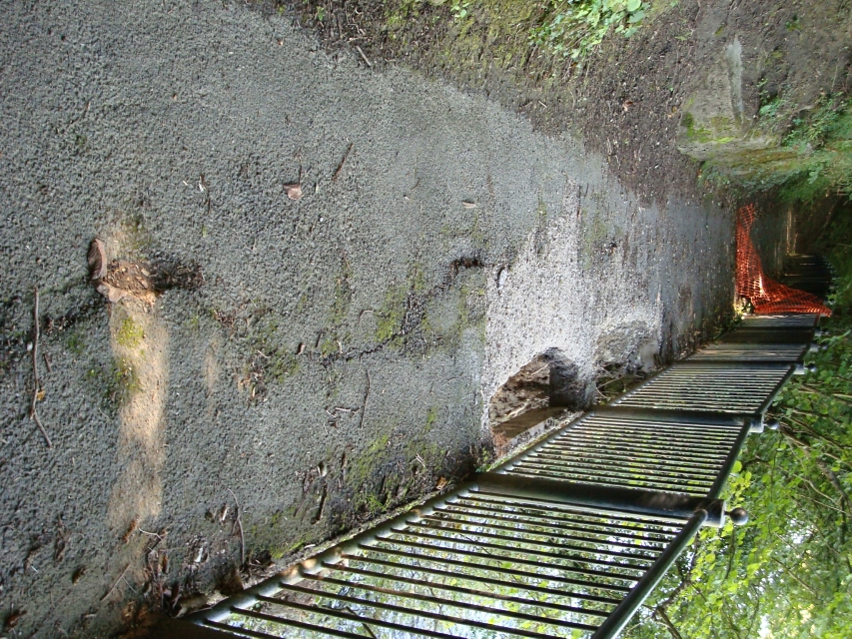
local collapse
A short section of the path running alongside the River Ribble has partially collapsed following the uprooting of a large tree on the river bank beneath it. The path has been closed on safety grounds.

Whilst there is a second path at higher level set back from the river, the riverside path offers good views of the river and is considered to be a valuable asset to the park which should be maintained if possible.
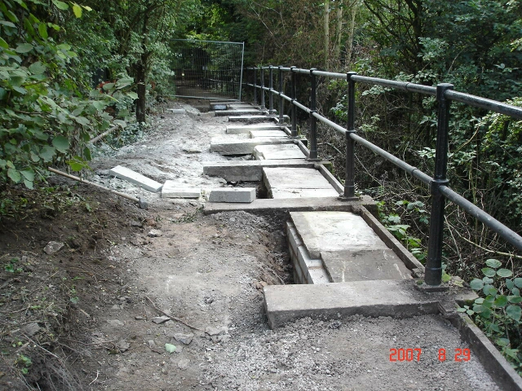
Cross Hill Quarry walkway
during refurbishment

The river side of the path at that point is supported on a number of 2m long bridges spanning between low masonry walls and is similar in construction to a walkway in the adjacent Cross Hill quarry that has just been refurbished by Lancashire County Council. LCC were asked for advice on possible repairs to allow the riverside path to be reopened.

Underlying Strata

The path runs approximately 5m above river level with an almost vertical face beneath it. The river at this point runs along a fault line in limestone rock which slopes steeply to the South. The river appears to have cut some way into the rock to the South of the fault line but OS maps indicate that the alignment is unchanged since 1845. The park occupies the steeply sloping bank formed by the rock outcrop to the South of the river There are extensive quarry workings 300m upstream on the South side of the river and directly opposite the collapse on the North bank. There is a narrow deposit of material between the river and the quarry on the north side. The steepness of the bank in the park indicates that the underlying rock strata may be close to the surface. Rock outcrops are also visible on the river bank approximately 100m upstream of the collapse.

The nature of the material immediately beneath the failure is critical to any proposed repairs. If there is rock above bed level further southerly movement of the river is unlikely and some sort of long term structural solution should be possible. If the rock is further down, the river will continue to scour the bank and further collapses will occur. In this case, no long term solution will be possible and closure of the path is considered to be the only available option.

Structural Repairs to Path

If suitable rock is found immediately below the path, above river bed level, a number of structural solutions for reinstating the path are available. The option chosen will depend on the level and slope of the rock and the nature of the material above it. The higher the rock and the better the material above it, the more likely it is that the path can be reinstated in its present form. If the rock is low but level, a structure supported on piers may be appropriate. If there are better foundation conditions either side of the collapse area, it could be bridged.

A more detailed appraisal will be provided after the results of the initial borehole survey are known.

Steep Banks Within the Park

Immediately behind the path is a steep wooded bank rising to the higher level path. There are linking paths at either end of the park but there are no paths in the area of the failure. A number of drainage gullies run down the slope and it is believed that one of these, adjacent to the collapse, contributed to the failure of the tree. This bank is extremely steep in places, particularly immediately behind the path, and its stability is an issue if the path remains open.
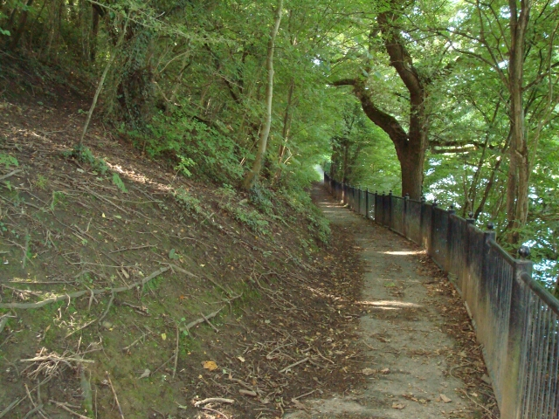
Steep bank behind the path

Trees Below The Path

There are approximately 8No. large trees rooted in the river bank below the path in the area of the collapse. It was the failure of a similar tree that caused the collapse of the path. Whilst the tree roots are of benefit in slowing down scour rates, the weight of the tree above causes catastrophic collapse when the roots are finally undermined. Removal of the bulk of the trees, whilst retaining the roots, would significantly reduce the likelihood of further damage to the path and have the added benefit of opening up the view of the river. Felling the trees would be difficult, requiring access from the North side of the river both for the plant required to fell the trees and for the removal of the trees themselves.
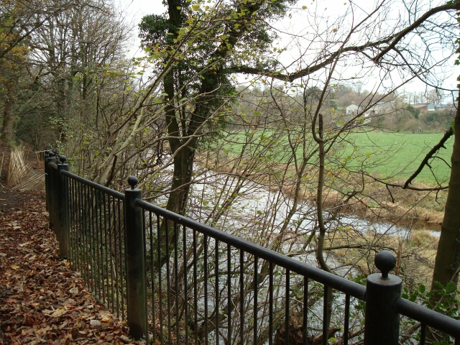
large trees below path

Access for the Work

Access to the site is available from both Waddington Road and West Bradford Road, but is severely limited in width in both directions. This will have an impact on the type of site investigation which can be carried out and the nature of any proposed remedial works. It will have even more impact on the removal of the river bank trees. This operation is considered essential but suitable plant cannot gain access along the South bank of the river. Felling and removal of the trees will have to be carried out by coming across the river from the North bank.

Services

There are no services in the area of the collapse or the bank behind it but a 500mm water main crosses the park and the river about 100m to the West of the site and there are various other services crossing or running along the access tracks.

Proposed Investigations

It is proposed that the investigation works should be phased and amended to suit the results as they become available.

 | Operation | Estimated Cost
1 | Desk study to establish underlying rock strata, services etc | £1,000
2 | Boreholes and dynamic probes at collapse site to establish ground conditions | £2,000
3 | Topographical survey of path and bank behind it | £2,000
4 | Trial pits and hand augers to establish stability of bank behind riverside path | £10,000
Note: Items 3 and 4 will only be carried out if Item 2 establishes that repair of the path is feasible
All estimates are preliminary and will be refined as work progresses.

Estimated Cost of Works

Subject to rock being found at a suitable level, the following work, in addition to the investigations noted above, will be required.

 | Operation | Estimated Cost
1 | Structural Repairs to the path | £15,000 to £40,000 depending on complexity
2 | Removal of trees between the path and the river | £10,000?
Note All estimates are preliminary and will be refined as work progresses.

Options If Path Repair Is Not Feasible

In the event that the collapse site is not stable and no repair is feasible, the following options have been considered:

 | Option | Comment/Estimated Cost
1 | Divert path locally around collapse | Not considered feasible due to the steepness of the bank
2 | Close path either side of the collapse | This is the easiest solution. However, it is not considered safe as some users will attempt to find ways round the gap. The bank stability investigations will also be required as the bulk of the path will remain open. If the trees on the river bank are not removed, further collapses are likely.  Cost approx £1000 plus bank stability investigations.
3 | Close the path at each end but don’t remove the path | This is the cheapest solution but it is not considered safe as some users will find ways round the closures or down the bank from the upper path and continue to use the path.  Cost approx £1000
4 | Close the path at each end and remove the path and handrail | Safe option.  Cost approx £10,000+
Note All estimates are preliminary and will be refined as work progresses.
LOCAL FAILURE OF THE RIVERSIDE PATH
THE PARK, WADDINGTON ROAD, CLITHEROE

EXECUTIVE SUMMARY

Problem

A 250m length of riverside path is closed due to the partial collapse of a short section.

Issues

1. The path is generally immediately adjacent to the river and 5m above bed level. The section that has collapsed is only worth repairing if the bank is stable. ie rock is above bed level.

2. Structural repair of the path will be difficult and expensive.

3. The collapse was caused by the failure of a large tree below the path. 8 trees, which are similar in size and location, need to be removed if further collapses are to be prevented. Access to remove the trees would need to be from the opposite bank of the river.

4. There is a steep bank behind the path which will require a stability analysis prior to reopening the path.

5. Safe closure of the path, if needed, is difficult and expensive.

Proposals

1. Carry out a site investigation on the path to establish if repair is feasible.

2. If repair is feasible, prepare a detailed repair and stability analysis estimate and obtain an estimate for removal of the trees.

3. If estimates are acceptable, remove the trees, carry out the stability analysis and repair the path.

4. If repair is not feasible, or costs are unacceptable, close and completely remove the path.

S Baker
December 2007

