DECISION
RIBBLE VALLEY BOROUGH COUNCIL
REPORT TO POLICY AND FINANCE COMMITTEE
Agenda Item No.

meeting date: | 20th November 2007
title: | Comprehensive Performance Assessment  – Corporate Self Assessment
submitted by: | Chief Executive
principal author: | Jeff Fenton – Corporate Services Manager
- PURPOSE
  - To seek approval to the draft Corporate Self Assessment document that is required to be submitted to the Audit Commission as part of this Council’s application for re-assessment under the Comprehensive Performance Assessment (CPA) framework.
- Relevance to the Council’s ambitions and priorities:
- Council Ambitions:
Comprehensive Performance Assessment is an assessment framework developed by the Audit Commission to judge how well councils are serving their communities. In so doing the CPA measures how well the Council is delivering on its Ambitions, Priorities and Future Plans and is therefore an important external validation of our achievements in these areas.
- Community Objectives:
- Corporate Priorities:
- Other Considerations:
- BACKGROUND
  - At their meeting of 26th September 2006 the Committee received a report of the Chief Executive outlining revisions to the CPA framework. As part of the revisions councils were invited to apply for re-categorisation if they considered that they had implemented sufficient improvements to warrant re-assessment. The Committee approved the recommendation to apply for re-categorisation in June 2007.
  - The meeting of this Committee on 12th June subsequently approved the application for re-categorisation. The application was submitted to the Audit Commission who considered that it met the relevant criteria to merit a re-assessment. This was confirmed by letter in July.
- Overview of the CPA process
  - The Comprehensive Performance Assessment (CPA) process is an assessment framework governed by the Audit Commission that assesses the overall quality of services provided by councils. The process comprises two stages as shown diagrammatically below.
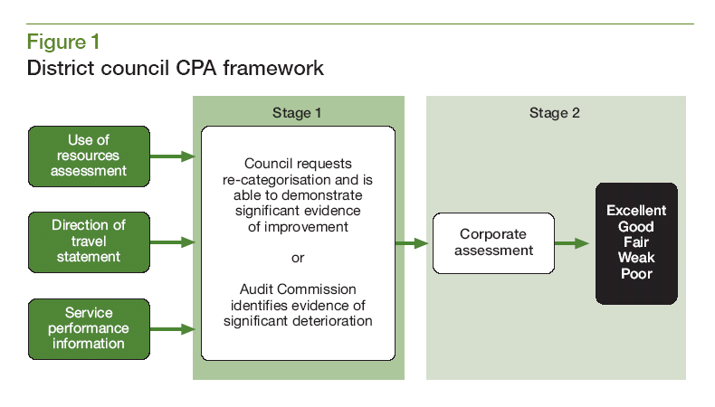
  - The successful application for re-assessment in June means that the Council has completed Stage 1 and has now reached the second and final stage – the Corporate Assessment. This comprises two distinct components – a Corporate Self Assessment wherein the Council provides evidence of its performance and achievements, and an external inspection by the Commission that validates this evidence.
  - The format and content of the Corporate Self Assessment is set out in guidance provided by the Commission. It should be organised in two sections: a Context and Summary section outlining general background information and the environment in which the Council operates; and the Assessment itself addressing the three headline questions and five themes of the Key Lines of Enquiry (KLOE); namely:
- What is the Council, together with its partners trying to achieve? This measures Ambitions for the community and Prioritisation.
- What is the capacity of the Council, including its work with partners, to deliver what it is trying to achieve? This measures Capacity and Performance Management.
- What has been achieved? This measures Achievement and Improvement.
  - Each of the five KLOE themes will be scored and assigned a weighting according to the tables given below.
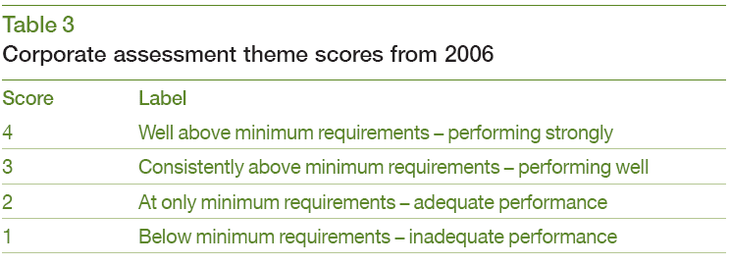
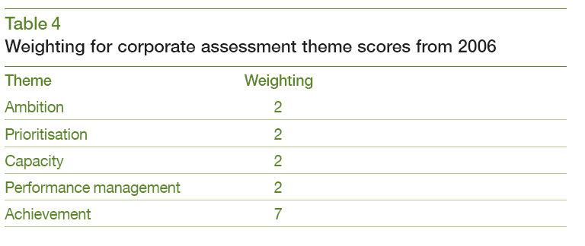
  - The overall categorisation for the Council will be awarded based on the total score according to the following categories: Excellent 45-60, Good 36-44, Fair 28-35, Weak 21-27 and Poor 20 or less.
  - Ribble Valley’s Corporate Self Assessment has been prepared in accordance with the guidance based on information provided by relevant officers. The draft has already been subject to extensive consultation with stakeholders both within and outside the Council including the Leadership, Committee Chairs, thematic group Chairs from the Ribble Valley Strategic Partnership and a representative of a peer authority. The draft (attached at Annexe 1) is presented here for final comments and approval.

  - With the approval of Committee the draft will be passed to an external printer for professional design and publishing, during which a small number of photographs will be added to improve the overall appearance of the document. Copies of the completed document will be circulated widely to Members, partners and other stakeholders. The Committee is asked to approve the delegation of final amendments and proofing to the Chief Executive.
  - Following the submission of the Self Assessment by 5th December, the Inspection Team will begin their validation of the evidence. This will include a tour of the Borough and an on-site inspection during week commencing 28th January 2008. The Commission will publish the results of the CPA in May.
- RISK ASSESSMENT
- Resources: None
- Technical, Environmental and Legal: None
- Political: None
- Reputation: The reputation of the Council can only improve if we succeed in being re-categorised as ‘Good.’
- recommendATION
  - The Committee are asked to:
- approve the draft Corporate Self Assessment as attached at Annexe 1;
- delegate the final proofing and amendments to the Chief Executive prior to publication and submission of the document to the Audit Commission.

David Morris
Chief Executive

List of Annexes
- Ribble Valley BC: Comprehensive Performance Assessment - Corporate Self Assessment (Draft)

For further information please contact Jeff Fenton, Corporate Services Manager tel. 01200 414593.

